Basic Electricity and Instrumentation – Part 1.

Exam Questions 2006 Spring

1. Electric potential and voltage in static electric field.
The electric field intensity between two parallel metal plates 3 cm apart is E= 2000 V/m. Calculate the voltage between the plates.

2. Definition and unit of electric current.
How much is the current in a conductor if Q = 5.0 C charge flows across it in Δt = 2.5 s?

3. What is resistance? State Ohm’s Law.
The voltage across the ends of a metal wire is V= 0.36 V, and I = 0.3 mA current flows through it. Determine the resistance of the wire.

4. How does the resistance depend on the cross section and length of the wire? Define resistivity.
You have two wires, both of the same material and of circular cross section. Which has got greater resistance? The one of length L₁=10 m and diameter d₁ = 1 mm or the other of length L₂ = 20 m and diameter d₂ = 2 mm?

5. How do electrolites, metals and semiconductors conduct electricity?
A piece of silicon has got 1.3 ⋅10¹⁵/cm³ free electrons. The concentration of free electrons in an other one is 1.3 ⋅10²⁰/m³ . Which piece of silicon has got higher resistivity?

6. Kinds of resistors and their symbols in electric circuits.

7. Power rating in a resistor.
The maximum allowed power rating in an R= 10.5 Ω resistor is P=0.5 W. Determine the highest voltage across it.

8. Characteristics of the resistors used in electric circuits. What is nominal value and tolerance?
The nominal value of a resistor of 10% tolerance is 47 kΩ. Give the interval of the possible resistance value.

9. Temperature dependence of the resistance. Does the resistance increase or decrease with temperature? Say examples.

10. Sources of electricity. What do we call an ideal voltage source and an ideal current source?

11. Galvanic cells.

12. The electromotive force, terminal voltage and internal resistance of a voltage source.
A voltmeter connected across the terminals of an unloaded battery reads Uo = 4.75 V. If a light bulb of resistance R=6.0 Ω is connected to the battery the voltage drops to U1 = 4.5 V. Determine the internal resistance of the battery.

13. What does it mean that two resistors are connected in series or in parallel? How do you calculate the resultant resistance in both cases?

14. Two resistors R1=10 Ω and R2= 40 Ω are connected in series. The voltage across R₁ is V₁=5.0 V. How much current flows through the other resistor and how big is the voltage across it?

15. Two resistors R1=10 Ω and R2= 40 Ω are connected in parallel. The voltage across R₁ is V₁=5.0 V. How much current flows through the other resistor and how big is the voltage across it?

16. Kirchoff’s Laws.

17. Thevenin’s theorem.

18. Measuring voltage and current.

19. Extending the range of meters.

20. Use of potentiometer as variable resistor and voltage divider.

21. The use of potentiometer to measure voltage.

22. The Wheatstone Bridge.

23. Capacitance and capacitors. Relation between the voltage across the capacitor and the current flowing through it.

24. A capacitor of C=100 μF is connected through a resistor of R=10 MΩ to a battery with emf=12 V. Determine the time constant. Show the time dependence of the voltage across the capacitor after switching in.

25. The inductor. Relation between current flowing through a coil and the voltage across it.

26. What is DC and AC current and voltage? What are the quantities characterizing sinusoidal AC voltage and current? What is the rms value? How do you get the power of the AC current or voltage in a resistor?
The rms value of the AC current flowing through a 2 kW heater connected to the 230 V mains is 2 A. How much is the resistance of the heater ?

27. Complex notation for AC current and voltage. The complex impedance.
The time dependence of the voltage across a coil of inductance L=0.15 H and resistance R=10 Ω is U(t) = 10.0 ⋅cos(1000t). Write it in complex notation. Determine the impedance of the coil. Give the time dependence of the AC current flowing through the coil.

28. Resonant circuits.

29 The transformer.

30. Electric conduction in semiconductors.

31. The pn junction and the junction diode.

32. Types and characteristics of diodes.

32. The bipolar transistor and its characteristics.

33. The field effect transistor.

34. Use of the diode as a rectifier.

35. Filters. Transfer function.

36. The amplifier. What is gain?

37. Feedback.

38. Oscillator.

38. The operational amplifier.

39. The gain of the operational amplifier with negative feedback.

40. Parts of a power supply unit.

Problems

1.
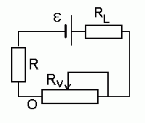

ε = 12.0 V, R_{L} = 8.0 Ω, R_{p} = 10.0 Ω, R = 2 Ω. In what range can be the current set with the potentiometer?
At which value of Rv is the power on R_{L} equal to P=18 W?

2.
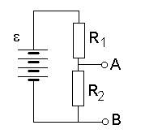
The emf of the voltage source is ε = 12.0 V. You need 6 V across A and B. Calculate the resistance R₁ if R₂= 300 Ω.

3.
ε = 12.0 V, R₁=100 Ω, R₂= 300 Ω. Replace the one-port AB with its Thevenin equivalent voltage source. How much current will flow through a resistor R=125 Ω connected between A and B?

4.
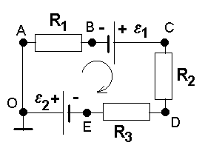
ε₁ = 12.0 V, ε₂ = 9.0 V, R₁ = 10 Ω, R₂=20 Ω, R₃ = 40 Ω. Calculate the current flowing in the circuit and determine the voltage U_{BE}.

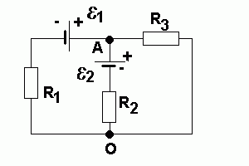

5.

ε₁ = 12.0 V, ε₂ = 9.0 V, R₁ = 10 Ω, R₂=20 Ω, R₃ = 40 Ω.
Calculate the current flowing through each resistor and show the direction. Determine the voltage U_{AB.}

6.
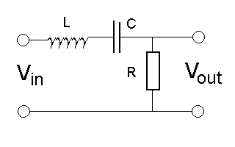

L = 4 mH, C=25 nF, R=100 Ω.

Determine the input impedance at 20 KHz. Calculate the rms output voltage is the input voltage is 12 V (rms).

Sketch the transfer function (Vout/Vin) as function of the angular frequency. Determine the position of maximum transfer and the quality factor Q .

