1. Introduction

1.1 The scope of this course is the theory of measurement as well as the most important methods and instruments used in the chemical industry. In these lectures we can not deal with each aspect of the theory and all existing methods in detail. We concentrate only to the fundamentals of the theory and a part of the industrial instruments. The nuclear radiation instruments and the methods used only in laboratories are not included. The methods which transform the measured variables to electric signals are preferred.
1.2 The object of our measurement is the quantities or variables that we want to know or to observe continuously. The variables usually depend on the time, this kind of variables are named process variables in the chemical industry and signal in the electronics.
1.3 What is the aim of the measurement of the quantities or the process variables? In a chemical research laboratory the measured quantities provide information about the structure of the molecules in the samples or about the physical and chemical properties of the materials investigated. In an analytical laboratory the measured quantities give us qualitative or/and quantitative information about the composition of the samples. In a quality control laboratory the measured quantities informs us about the quality of the products relative to the requirements.
In the chemical industry, however, the purpose of the measurement is different. The manufacturing processes in the chemical industry apply well-known technologies. If quantities and the qualities of the input materials correspond to the technology and the process is running in accordance with this technology the good result is guaranteed. The process variables measured during the manufacturing indicate the desirable or undesirable changes in the operation, and show continously the deviations between the actual and the ideal values of the technological parameters. The quality of the products, the optimum of the input and output materials, the minimal cost can be guaranteed by the minimization of the deviations from the values specificated by the technology. After the end of the process it is not possible or it is very expensive to repair or to refine the products in the chemical industry. Thus it is necessary to modify the process parameters immediately after the observation of the deviation surpassing a given level. The continuous instrumental control is also important in the respect of the process control, in the process industry the process control is inseparable from the instrumentation.
1.4 What are the most important process variables in the chemical industry? Table 1 shows the result of an investigation for the relative occurrance of some process variables in the chemical industry.

Table 1

Temperature | 50 %
Volume and mass flow | 15 %
Pressure and pressure difference | 10 %
Levels | 6 %
Volume and weight | 5 %
Time | 4 %
Chemical composition | 4 %
Other variables | 6 %
 | 100 %

During the course we deal with the measurement of temperature, mass and volume flow, pressure and pressure difference, level in some tank, chemical composition and other variables (humidity, pH, etc.) in industrial circumtances. The measurement of time, volume and weight are not difficult problems in the chemical industry, so the measurement of these quantities are not included in the course.
1.5 What is the definition of measurement? By the classical definition of measurement is: "the measurement of a physical quantity consists of the determination of a numerical ratio between the effects of two samples to the instrument, one of which is the sample to be measured and the other is an unit sample”. The definition is not sufficient in all cases. It is possible to determine a quantity by instruments working on the basis of different principles. For example, the mass M of an object can be measured by a dynamometer or by a balance. In the first case one determines a ratio, namely the stretching of the dynamometer spring loaded with the object (L_{M}) divided by the stretching caused by unit (L_{U}):

M = L_{M}/L_{U .}

The determination of a mass by dynamoter follows the classical definition. In the second case one count how many units (analytical weights) have to be placed into the pan for balancing the object:
M = number of units for balancing.

The result of this latter measurement is not a ratio. This is in contradiction with the classical definition. As a more general definition it can be said that the measurement of a physical quantity is always a counting process and the result is always a pure number. E.g. in the first case the counting of the marks on a scale calibrated by the unit.
The number M depends on the unit used. If the unit used will change, the number M will also change.
1.6 An international system called Système International d'Unités will be used during this lecture. The system (SI) has been accepted and used in a great majority of the countries.
In the research and the industry the people have to measure many different physical and chemical quantities. All quantities can be defined in terms of a small number of fundamental units. The choice of these fundamental units is arbitrary, but the funtamental units have to be independent. The SI system selects a minimal basis set so that all quantities in this set are dimensionally independent. This condition means that they can not be derived one from others by algebraic combinations. The dimension of any other physical quantity can be expressed in terms of this basic set.
The definition of any quantity must be operational, i.e. the definition has to contain the description of the operation (and the apparatus) that is carried out to measure the quantity.
The fundamental physical quantities, their symbols, SI units (primary standards), abbreviations and the years when their currently accepted definitions have been introduced are summarized in Table 2.

Table 2

Quantity | symbol | SI unit | abbreviation | year
Length | l | meter | m | 1983
Mass | m | kilogram | kg | 1899
Time | t | second | s | 1946
Electric current | I | amper | A | 1946
Thermodynamic temperature | T | Kelvin | K | 1967
Amount of substance | n | mole | mol | 1967
Luminous intensity | I | candela | cd | 1983

1.6.1 The standard meter was redefined in 1983 as a length of path traveled by the light in vacuum during a time interval of 1/299 792 458 secundum. The velocity of light in vacuum was fixed in 299 792 458 ms⁻¹.
1.6.2 The standard kilogram is a bulk of platinum-iridium kept at Sèvres.
1.6.3 The standard second has been defined as the duration of 9 192 631 770 periods of the radiation corresponding to the transition between two hyperfine energy levels in the ground state of the ¹³³Cs atom.
1.6.4 The standard amper is defined as the constant current which would produce a force of exactly 2.10⁻⁷ Newton between one meter length sections of two parallel conductors of infinite length, of negligible circular cross section.
1.6.5 The standard Kelvin is 1/273.15 of the thermodynamic temperature of the triple point of water, the point in which liquid water, water vapour and ice are in equilibrium.
1.6.6 The standard mol is the amount of substance which contains as many entities (atoms, ions, radicals) as carbon atoms are in exactly 0.012 kg of ¹²C.
1.6.7 The light intensity of a source in a given direction is one candela if the source emits monochromatic light at 550 THz and its power in this direction is 1/683 watt per steradian.
Table 3

Prefix | Abbreviation | Multiple
ato | a | 10⁻¹⁸
femto | f | 10⁻¹⁵
piko | p | 10⁻¹²
nano | n | 10⁻ ⁹
mikro | μ | 10⁻ ⁶
milli | m | 10⁻ ³
kilo | K | 10⁺ ³
mega | M | 10⁺ ⁶
giga | G | 10⁺ ⁹
tera | T | 10⁺¹²
peta | P | 10⁺¹⁵
exa | E | 10⁺¹⁸

The complete definition of the fundamental units contain also the descriptions of the apparatus and the way of the measurement.
Multiples and submultiples of the units are also used in the practice. The exponent change always with 3 in the decimal system. Prefixes are applied to abbreviate the multiples and submultiples (see Table 3).
The fundamental units have distinctive names. There are 17 further nonfundamental quantities which have also distinctive unit names (newton, joule, watt, pascal, hertz, coulomb, volt, farad, ohm, henry, weber, siemens, tesla, lumen, lux, becquerel, gray). In the case of the above nonfundamental units the use of the prefixes is possible as well.
1.7 What are the parts of an instrument? The Figure 1.1 shows a possible division of the instrument into functionally separate parts.

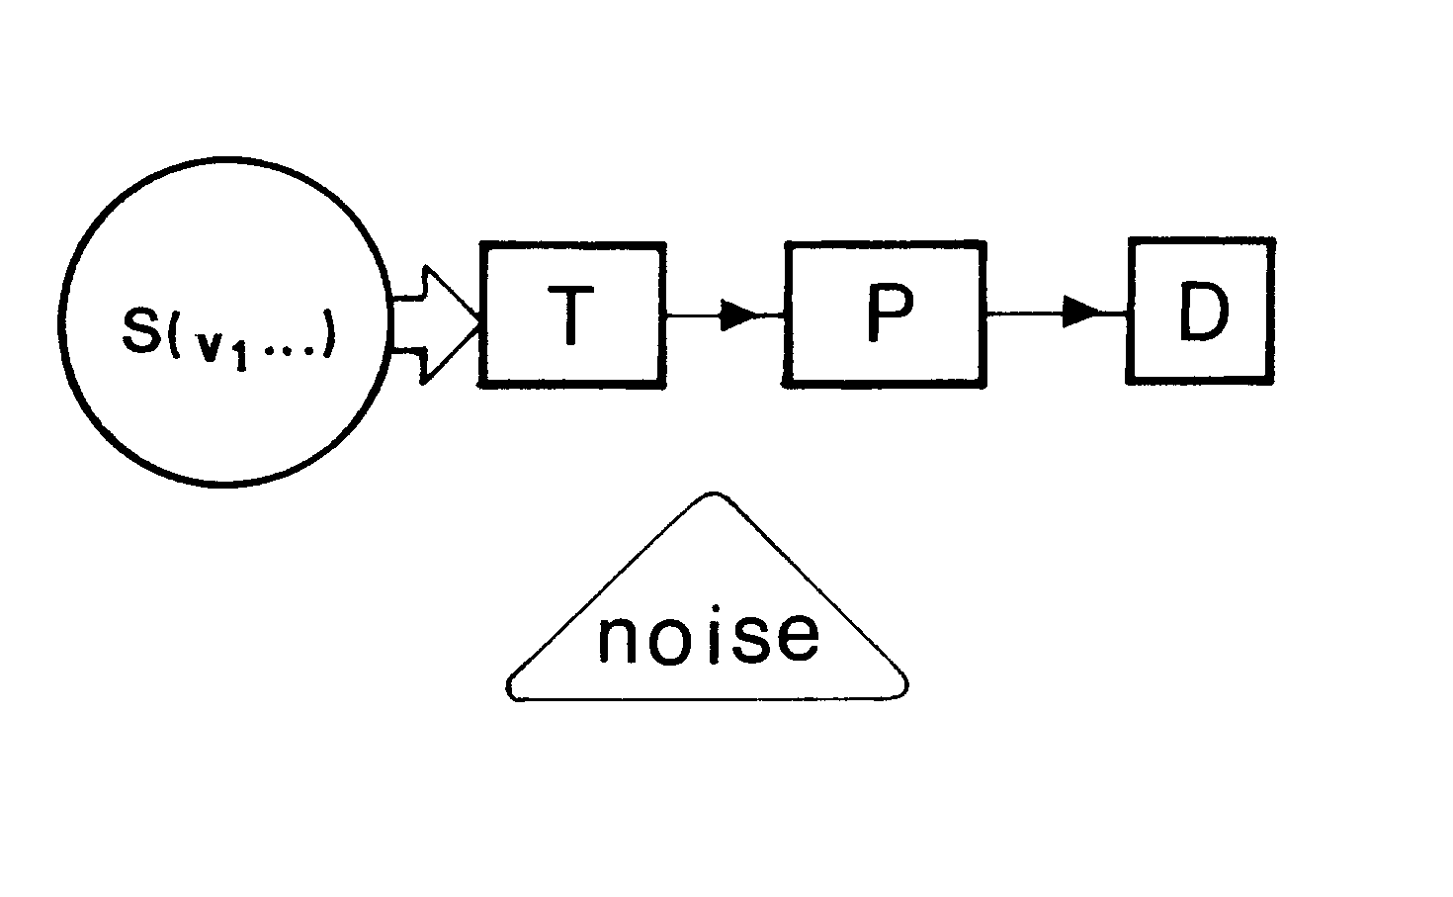
Fig. 1.1

1.7.1 It may be surprising, but the system S, the variables (v₁,...v_{n} ) of which we want to measure is a part of the instrument. The applied method and the instrument are not independent of the system that we want to investigate.
1.7.2 A fundamental part of the instrument is the detector or input transducer. The different variables of the systems may be mechanical, pneumatical, thermal, electrical, optical, chemical, etc. ones. The modern trend of the instrumentation is to convert the nonelectric signals into electric ones.
It is more convenient to amplify, to transmit, etc. the electric signal than the original one. Thus the detector produces generally electric signal in its output. This is why we are deal only with electric or electronic instruments in the present course.
1.7.3 The following part of the instrument modifies and processes the output electrical signal of the detector. Several different modifiers can be distinguished. The converters transform the electric signal in to a more convenient form. There are current-voltage and voltage-current converters, AD-DA converters, voltage-frequency converter, transmitters, modulators, etc.) The amplifiers and the transformers increase or decrease the magnitude of the signal. The filters modify the spectral distribution of the signal.
The fundamental task of the signal processing part of the instrument is to invert the converted, amplified, filtered electrical signal y(t) into the estimated value of the original input x(t). This inversion can be performed in analog or digital manner and is based on the fact that between y(t) and x(t) there is a unique relation

y(t) = f[x(t)]

in known or in unknown form. The displayed result of the measurement is

= f ⁻¹ [y(t)] .

The simplest example for this inversion is the scaling of a voltmeter or ammeter.
1.7.3 The outputs of the analog instruments are usually connected to analog meters or recorders for displaying the results of the measurement. The displaying of the result may be done not only by analog way but digital manner, too. At present the importance of the digital data acquisition by computer is increasing continously. The data acquisition can be accomplished at the output of the instrument or at the output of the detector. In the second case the analog signal processing of the instrument has to be subsituted by a digital signal processing realized in the computer. The digital data acquisition and the digital signal processing require a special device, the analog-digital converter (ADC). The ADC will be treated in the Chapter 12.
1.8 During the lecture the instruments will be classified in three different manners:
1.8.1 According to the way of the determination of the wanted quantity direct determination methods and indirect ones can be distinguished. In the first case the instrument measures and displays directly the value of the wanted quantity (e.g. current intensity by an ammeter). In the second case the value of the wanted quantity can only be calculated from more than one different measured values applying relations existing among these values (e.g. the determination the change of the neutralization enthalpy by calorimeter).
1.8.2 According to the realization of the signal (processing) inversion the instruments can be classified into three groups. The first group contains the direct deflection instruments. The needles of these instruments deflect proportionally to the wanted quantities. The inversion is equivalent to a scaling problem. The second is the group of the null balanced instruments. The inversion is executed by the null balancing of a bridge or a potentiometer. An important part of the instrument the null indicator (e.g. an ammeter). The third group contains the self-balanced instruments. The deflection of the needle of the null indicator is proportional to the deviation of the wanted value from the reference one. This is a useful method for measuring precisely deviations or changes.
1.8.3 According to the signal processing mode in the instrument we speak about analog or digital instruments. In the first case the signal processed in the instrument is analog one. The analog signal may change continuously between a maximum value and a minimum one. Fig. 1.2 shows an analog signal processing instrument, a Wheatstone bridge for measuring the resistivity of a thermoresistive thermometer. The balancing potentiometer is scaled for the temperature. The aim of the signal processig is to obtain from the R(t) resistance of the thermometer through the relation

the Δt tempetature in ºC. The Wheatstone bridge eliminates the first term in the above relation. Since there are a linear relationship between the left side of the equation and the Δt in the second term, the rest of the signal inversion can be realized by a simple scalling.
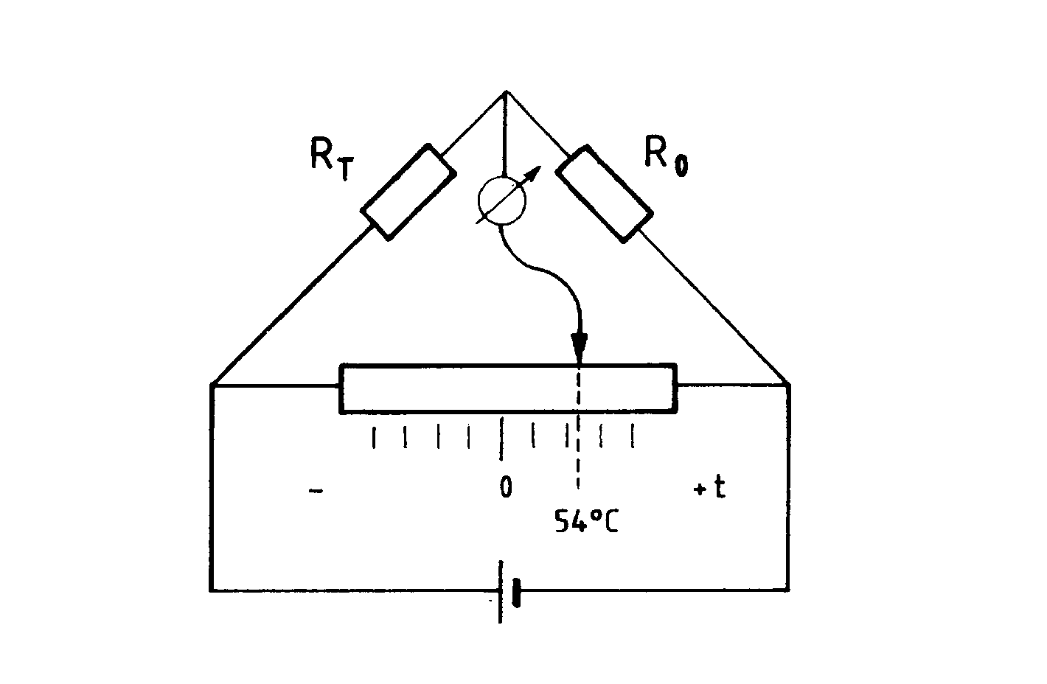
Fig. 1.2

In a digital instrument the analog output signal of the detector is converted into binary number by an analog-digital converter (ADC). The digital instrument is some kind of microcomputer which processes numerically the digital data. The result is visualized also in numerical form. Fig. 1.3 shows the block diagram of a digital thermometer. The instrument contains a highly stable constant current source (CCS), a miniaturized ADC, an one-chip microcomputer and a liquid crystal display. The digital signal processing- signal inversion by the microcomputer is a simple numerical solution of the above equation. The memory of the microcomputer contains the data R_{o} and α.
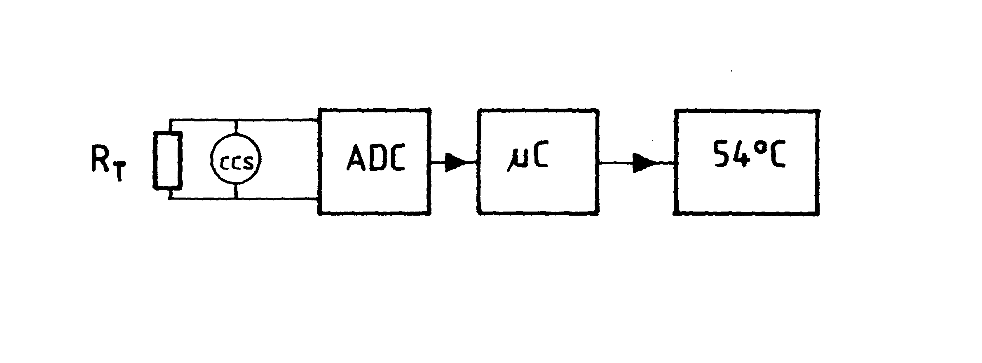
Fig. 1.3

1.9 There is no measurement without errors. The error is the deviation of the measured value from the wanted one
Δx(t) = x(t)- .

Some types of errors are collected here.
1.9.1 If an instrument is designed by supposing the validity of the relation

= f ⁻¹ [y(t)] ,

but the relation supposed is not perfectly valid, a systematic error is appeared. E.g. the needle of a voltmeter is deformed, so the original scaling is not valid. The systematic error can be eliminated by calibration.
1.9.2 If an instrument at constant input signal gives an output which changes monotonously and continuously, a drift error is generated. Probably the temperature of elements in the instrument are not in stationary state or some important instrumental parameters (e.g. voltage) change in the time.
1.9.3 If an instrument which gives an accurate response to a constant input but gives an erroneous response to a time dependent input signal, dynamic error is generated (see Chapter 3).
1.9.4 If the elements of the instrument and/or the system investigated are randomly disturbed by unwanted and unknown effects, random error (noise, stochastic signal) is generated. There is no measurement without noise. An important feature of the instrument is the noise rejection. (see Chapter 4.)

