2. Static properties of the instruments

In this Chapter and in the following one the construction and the working principle of the instrument is unimportant. We consider the instrument as a black box. The static properties of the instrument have been determined by constant input signals or signals changing only in a short time interval.
2.1 The working range of the measurement is an important static property of the instrument where x_{min} is the lower limit and x_{max} is the upper limit of the range.
2.2 The sensitivity of an instrument is given by the response at the output to the unit change in the input signal. The expression of the sensitivity S is

The index x_{o} indicates that the sensitivity may vary with the input signal x.

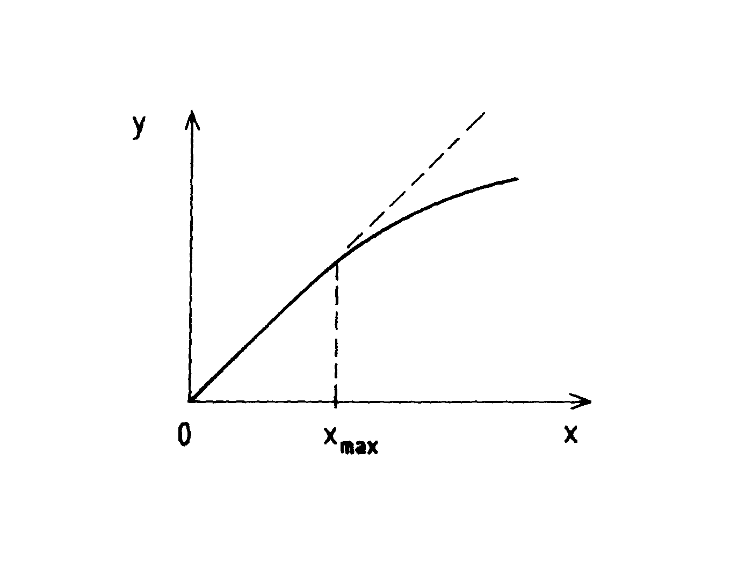
Fig. 2.1

2.3 If the sensitivity of the instrument is independent of the input signal the instrument is linear. It is preferable to use a linear instrument, but unfortunately it is not possible to make such one in all cases. There are two typical real types of instruments. One kind of instruments is linear in a limited range, but nonlinear out of this range (Fig. 2.1). Another kind of instruments is nonlinear in the full working range (Fig. 2.2). The nonlinearity of an instrument in its working range is given by the following relation

which is the maximum of the relative deviation from the linearity. (E.g. the nonlinearity of the scale of an instrument is less than 0.5 % )
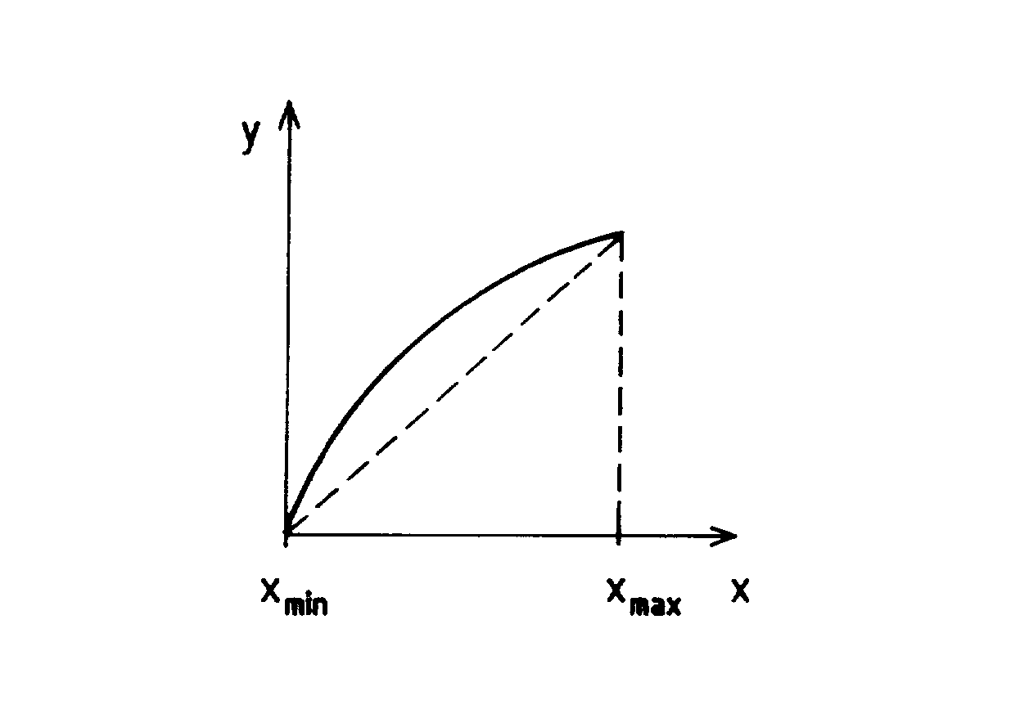
Fig. 2.2

2.4 Other important static property of the instruments is the resolution or the threshold. The words resolution and threshold are almost synonyms. The threshold is the smallest detectable change Δx_{min} in the input signal around the zero input value. The resolution, however, is a similar change in the input signal at any input value. It may be seen that there is only a small difference between the two definitions, but the resolution is more general.
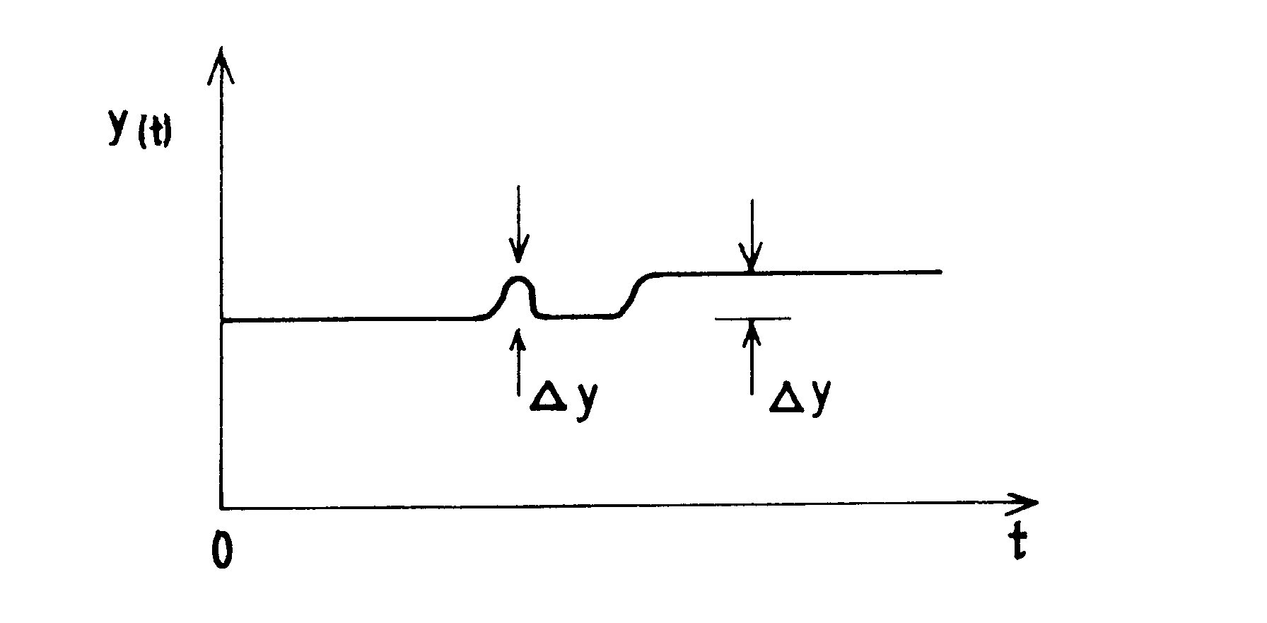
Fig. 2.3

The problem is that we can not observe directly the input signal, only the output one of the instrument. Because of this the resolution has to be expressed by the signal observed at the output. There are two extreme cases. In the first case the noise on the output signal may be neglected. So we can determine the smallest detectable change Δy_{min} of the output signal (see Fig. 2.3) from which the resolution is

In the second case the noise is comparable to the signal (see Fig. 2.4). The noise is a random (or nonrandom) fluctuation which disturbs the output signal. Let us introduce the concept of signal-to-noise ratio in the following form

where σ_{n} is the square root of the variance of noise (see Chapter 4). A widely used but rough estimation of σ_{n} is

where n_{pp} is the noise peak-to-peak, the double of the maximum amplitude in the noise recorded in the time. The condition of the observability of the change in the output signal buried by noise is

From this the resolution is

if the noise level is high.
2.5 A remarkable static property is the input and output load of the instrument. The electronic instruments have an input and an output loops. Theirs impedances are defined as the ratio of the voltage and the current at the input as well as the output. The input and output values are different in the case of electronic instruments. The magnitude of the input impedances would be very different according to the detectors.
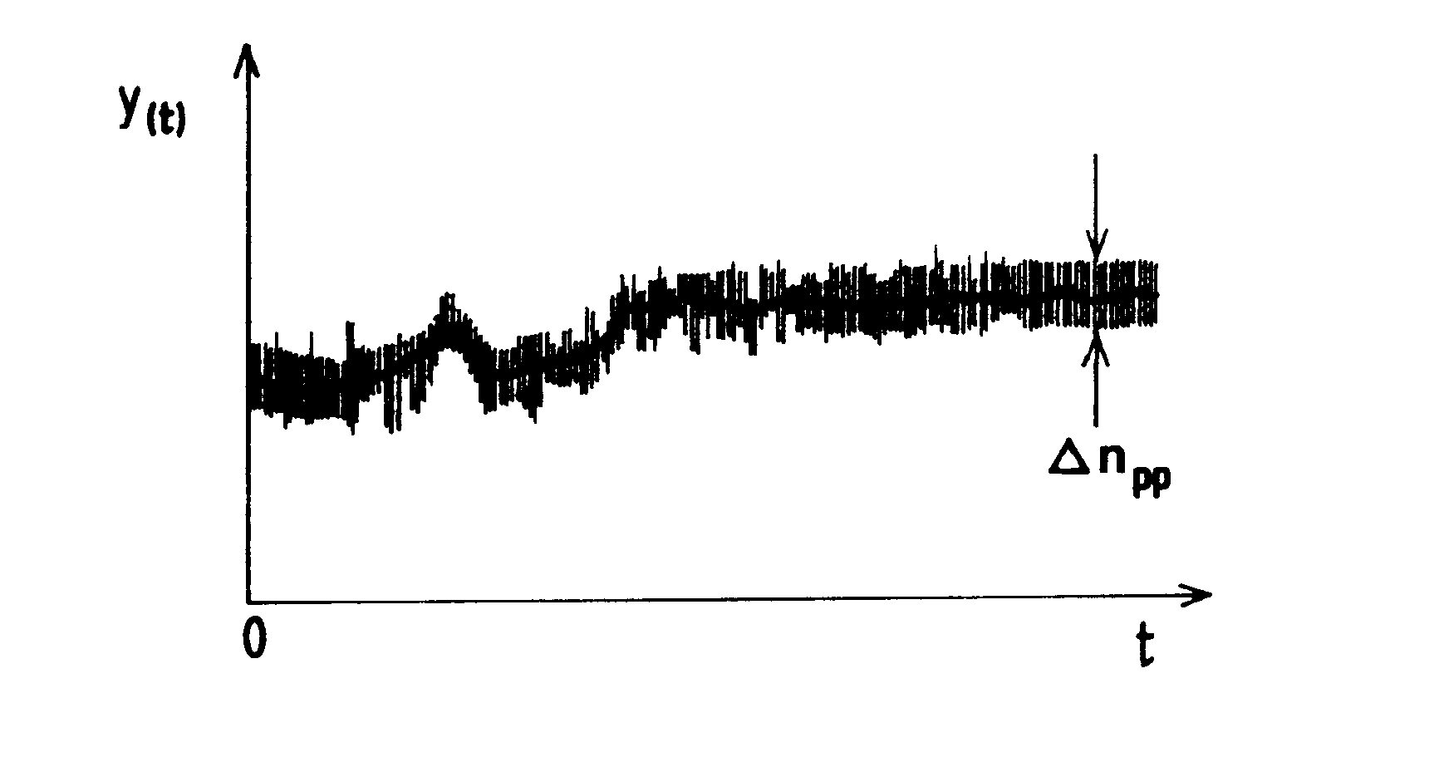
Fig. 2.4

A good example is the measuring of pH. The determination of pH is based on the measuring the electromotive force (EMF) between a pH sensitive electrode and a reference one. The EMF of an electrochemical cell can be determined by a pH meter only if practically no current flows through the input and the electrochemical cell. Because of this the input impedance of the pH meter has to be as high as possible. Applying FET transistors at the input of the electronic, 100 Gohm impedance or higher can be achieved, thus the input current is reduced to some pAs, thus the load is some pwatts.
The output impedance and the output power requirements are specified by the display or the recorder. The output impedance of a pH meter is usually 10-100 ohms. Since the voltage amplification of the pH meters is 1, the power requirement is between 0.1 and 0.01 watts. The input-output power difference is supplied by the electric network. We speak about power amplification.

