5. Measurement of temperature

5.1 International Temperature Scale (ITS90)

The temperature is the degree of hotness or coldness of materials expressed in appropriate unit. The unit of the thermodynamic temperature (Kelvin) is the fraction 1/273.16 of the value obtained by a linear thermometer at the triple point of water. This means that the concept of the thermodynamic temperature supposes the existence of a material or device which has a property depending linearly on the temperature. This property has to be zero at the absolute zero temperature. The behaviour of the perfect gas would be ideal for realizing a thermometer (constant volume gas thermometer) which can measure the thermodynamic temperature. Since there is no perfect gas in the nature and the vessel of the gas thermometer is filled by real gase (hydrogen, helium or nitrogen), corrections are applied to eliminated the deviation from the perfect gas behaviour. Two types of corections are used. The first correction is the extrapolation of the thermometer effect (pV) to zero pressure

and the second one is the heat dilatation correction of the vessel. Because of the experimental difficulties such thermometers work only in the standardizing laboratories.
An international agreement exists for a scale which reproduces the thermodynamic temperature as closely as possible.(International Temperature Scale, ITS). The instruments for the measuring and the ranges in which these instruments can be used as primary standards are also standardized. The primary standard instrument is a platinum resistance thermometer for use from 13.8088 K (triple point of the equilibrium mixture of ortho and para H₂) to 1234.93 ⁰C (silver freezing point). Above the silver freezing point a radiation thermometer is used. The operation principle of the radiation thermometer bases on the Planc’s radioation low of black body. Since the signals of these instruments depend nonlinearly on the thermodynamic temperature calibrations have to be applied at the fixed points given in Table 4. The list of revised calibration values was adopted in 1990.

Table 4

States | T₉₀(K) | t₉₀(⁰C)ª
Triple point of H₂ ^{b} | 13.8033 | -259.3417
Triple point of Ne | 24.5561 | -248.5939
Triple point of O₂ | 54.3584 | -218.7916
Triple point of Ar | 83.8058 | -189.2442
Triple point of Hg | 234.3156 | -38.8344
Triple point of H₂O | 273.1600 | -0.1000
Melting point of Ga | 302.9136 | 29.7646
Freezing point of In | 429.7485 | 156.5985
Freezing point of Sn | 505.078 | 231.928
Freezing point of Zn | 692.677 | 419.527
Freezing point of Al | 933.472 | 660.322
Freezing point of Ag | 1234.93 | 961.78
Freezing point of Au | 1337.33 | 1064.18
Freezing point of Cu | 1357.77 | 1084.62

ª t₉₀=T₉₀-273.15
^{b} hydrogen in an equilibrium mixture of ortho- and para-hydrogen

From Table 4 it is clear that phase transitions of well defined, pure materials have been proposed by ITS90 for calibration. Since the primary standard instruments are expensive, instead, secondary standard chains are employed. A given member of the chain has to be calibrated with help of the precedent member. The first member of the chain is always the corresponding primary standard. A part of the secondary standards are based upon the same principles as the primary ones the others are of different design like the liquid thermometers.

5.2 Thermoresistive devices
5.2.1 Metal resistance thermometers

The resistance thermometers utilize the dependence of electric resistance on the temperature. For pure metals this dependence can be expressed as

R(t) = R_{o} (1+AΔt+BΔt² ) ,

where R is the resistance in ohm at the reference temperature (usually at 0 ⁰C), R(t) is the resistance at the temperature t, A and B are the temperature coefficients of the resistance. The coefficient A of metal resistance thermometers is positive, thus the resistance of these devices increases with temperature. Only a few metals are suitable for making resistance thermometers. They have to fulfill several requirements:
i. The metal must have an extremely stable resistance temperature relationship in the used temperature range in other words neither the value R_{o} nor the temperature coefficients can change with repeated heating and cooling.
ii. The specific resistance of the metal must be high allowing to make small size thermometers.
iii. The temperature coefficient A must be high otherwise the thermometer is not sensitive.
iv. A low value for the coefficient B is advantageous because the thermometer will be approximately linear.
v. For the good reproducibility the purified metal has to exhibit small resistance changes with the contaminations which can not be totally removed during the manufacturing process.
vi. The purified metal has to be comercially available. Industrial resistance thermometers are commonly fabricated from platinum or nickel (R_{o}= 100 ohm).

5.2.1.1 Platinum resistance thermometer

Of all materials currently used platinum has the optimum characteristics in a wide temperature range, from -190 ⁰C to 900 ⁰C. The Pt resistance thermometer has a good linearity but its sensitivity is lower than the one made of Ni (see Fig. 5.1). The temperature coefficients are A=3.98.10 K⁻¹ and B=-5.8.10 K⁻² . Although Pt is a noble metal and can not be oxidized, it is subject to contamination at higher temperature by 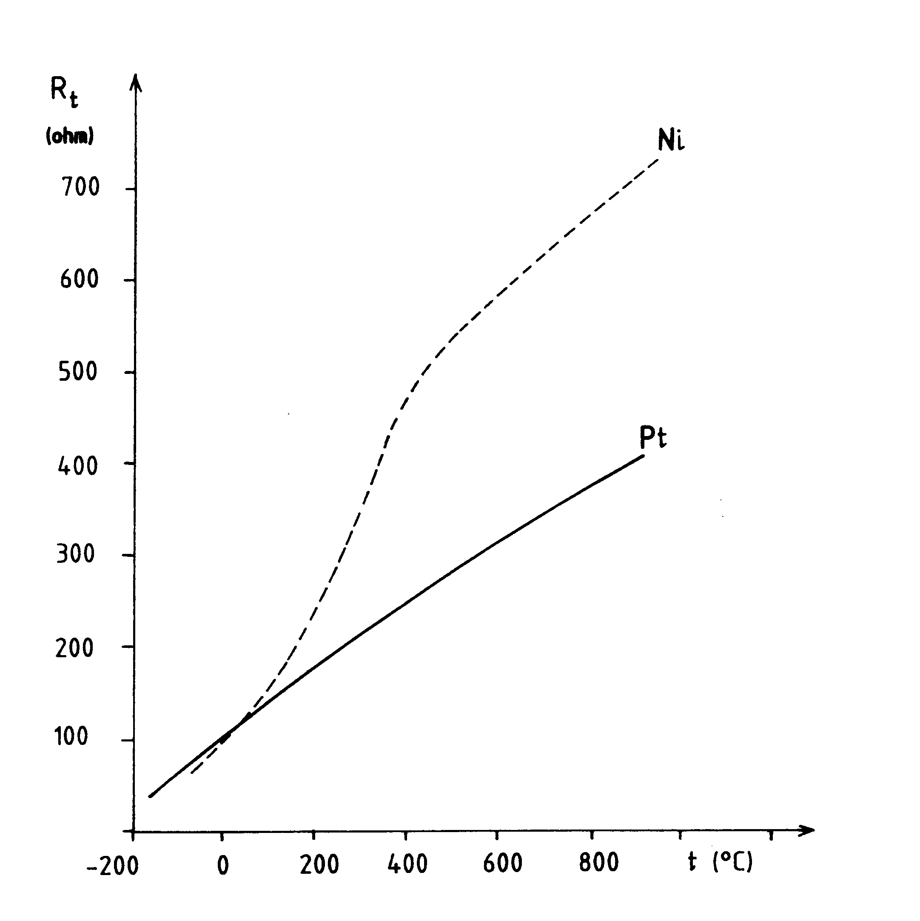
Fig. 5.1
some gases such as carbon monoxide and other reducting atmospheres and by metallic oxides.

5.2.1.2 Nickel resistance thermometer

For industrial temperature measurement in the range from -60 ⁰C to 200 ⁰C, Ni resistance termometers are satisfactory. The temperature coefficients of the pure nickel in this range are A= 5.46.10 K⁻¹ and B= 7.4.10 K⁻² . It is not possible to use the nickel at higher temperature because of a crystal structure transition at about 350 ⁰C . The quality of the commercially available nickel wires is not as reproducible as the one of platinium.
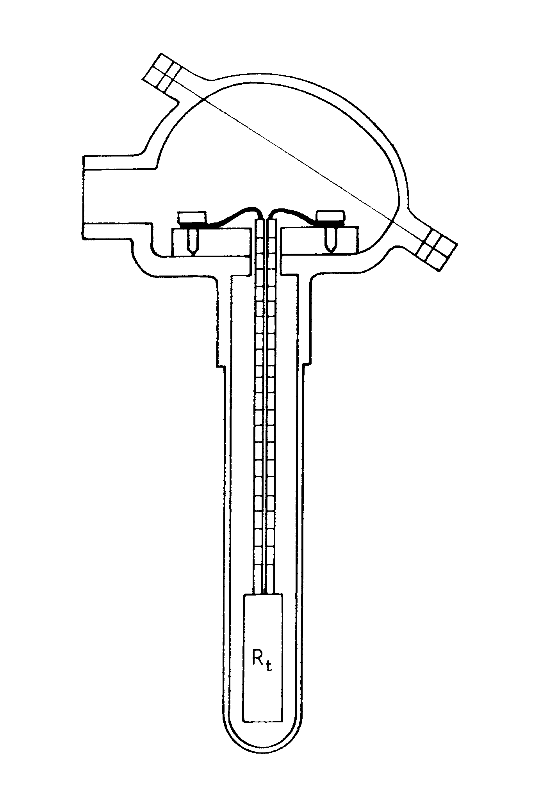
Fig. 5.2

The industrial resistance thermometer assembly includes a protection tube and a terminal connecting head, too (Fig. 5.2). Becuse of this the response time of the thermometer increases from about 0.1 s to several 100 s. This assembly is a two capacitive, second order device.

5.2.2 Thermistors

The thermistor is an electrical device made of semiconductor ceramic with a high temperature coefficient of resistivity. The name of "thermistor" is derived from "thermally" sensitive "resistor". The resistance-temperature relations for the thermistors are

or

where R(T) is the resistance at the temperature T, R_{o} is the resistance at the reference tem-perature T_{o} , R∞ is the resistance at the temperature approaching infinity, c and C are constants depending on the composition, the manufacturing process and the construction. According to the above expressions the sensitivity of the thermistors depends strongly on the temperature. The resistance-temperature function of the thermistors has a high negative coefficient as well as a high degree of nonlinearity. The specific resistance of thermistor decreases by a factor of 50 as the temperature increases from 0 ⁰C to 100 ⁰C.
The stability of thermistors with time depends on their composition, the manufacturing process and the particular application conditions. If the thermistor is subjected to relatively high temperature in cycle it may show relaxation. When the thermistor is held at a constant temperature with negligible current flow, its resistence may change in the magnitude of 1% per year. Because of this the present thermistors can not replace the metal resistance thermometers.

5.2.3 Measuring by resistance thermometer

Two methods commonly used in the chemical process industry are treated in this part. In both cases the current flowing through the thermometer is limited to 10 mA for keeping the error caused by the heating low.
5.2.3.1 Automatically balanced and self-balanced bridges

Figure 5.3 shows an automatically balanced system consisting of an Wheatstone bridge, an DC amplifier and a DC servo motor. For balancing the bridge there is a mechanical coupling between the axis of the servo motor and the potentiometer. The servo motor voltage is supplied by the DC output current of the amplifier. The DC amplifier consists of an operational amplifier (see Chapter 10). The operational amplifiers have two inputs, a noninverting and an inverting ones. The output current of an operational amplifier is proportional to the voltage difference between the two inputs at constant output load resistance. The mechanical momentum of the DC servo motor depends on the magnitude of the output current of the operational amplifier which varies following the balancing process. The direction of the rotation is determined by the sign of the voltage difference between the inputs of operational amplifier. If the balancing of the bridge is achieved the output current and thus the mechanical momentum of the motor is zero , the servo motor stops. The automatically balanced bridges are usually completed by strip chart recorders.
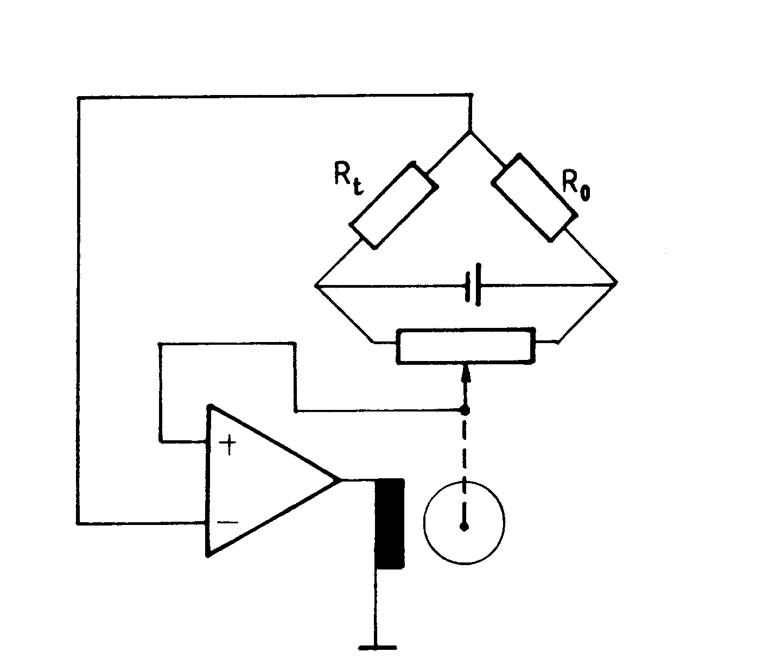
Fig. 5.3
The self-balancing bridge does not contain servo system. This bridge measures only the deviation of the thermoresistance from the reference value. The change of the temperature relative to a reference one can be measured by this device with high precisity. Because of the nonlinearity of the resistance-temperature relationship both methods require the calibration of the scale.

5.3.2.2 Digital thermoresistive thermometer

Figure 1.3 shows a digital thermo-resistive thermometer where R_{t} is a thermo-resis-tance and CCS is a highly stable constant current source power supply. The device contains a low cost AD converter and an one-chip microcomputer, too. The ADC converts the tem-perature depending voltage appeared on its input into digital value. The microcomputer which stores the values R_{o} , A and B in its memory converts the digitalized voltage to temperature. The result is visualized on a liquid crystal display. This device offers an effective alternative to the balancing bridge-type instruments. The simple digital thermometers are portable. The more complicate and expensive instruments using a muliplexer before the ADC can scan numerous individual thermo-resistance detectors located at different distances from the central digital processing units. The digital output of the instrument may be connected to the input of a digital printer or a process control computer.

5.3 Thermocouple
5.3.1 Thermocouple effect

The thermocouple is a device that converts the thermal energy directly into an electric voltage when a temperature difference exists between the two end junctions of the pair of different metal wires (see Fig. 5.4). The operation of the thermocouples is based on the Seebeck's effect. The Seebeck voltage E(t₂ ,t₁) has to be measured under zero-current con-dition that is the measured voltage has to be thermo-electromotive force (TEMF). Only the temperature at the hot junction relative to the one at the cold junction can be determined from this thermo-electromotive force. If we want to know the temperature t₂ from the determined temperature difference Δt it is necessary to stabilize the reference value at a well known temperature t₁ . The Seebeck voltage consists of four terms as follow

E(t₂ ,t₁ ) = U_{AB}(t₂ )+U_{BA}(t₁ )+U_{A}(t₂ ,t₁ )+U_{B}(t₁ ,t₂ )

where the first and the second terms correspond to the contact potentials of the two junctions. The indexing of the terms gives the direction of the moving in the loop. If it is changed from clockwise to counter-clockwise the sign of the potential changes, too.

U_{AB}(t) = - U_{BA}(t)
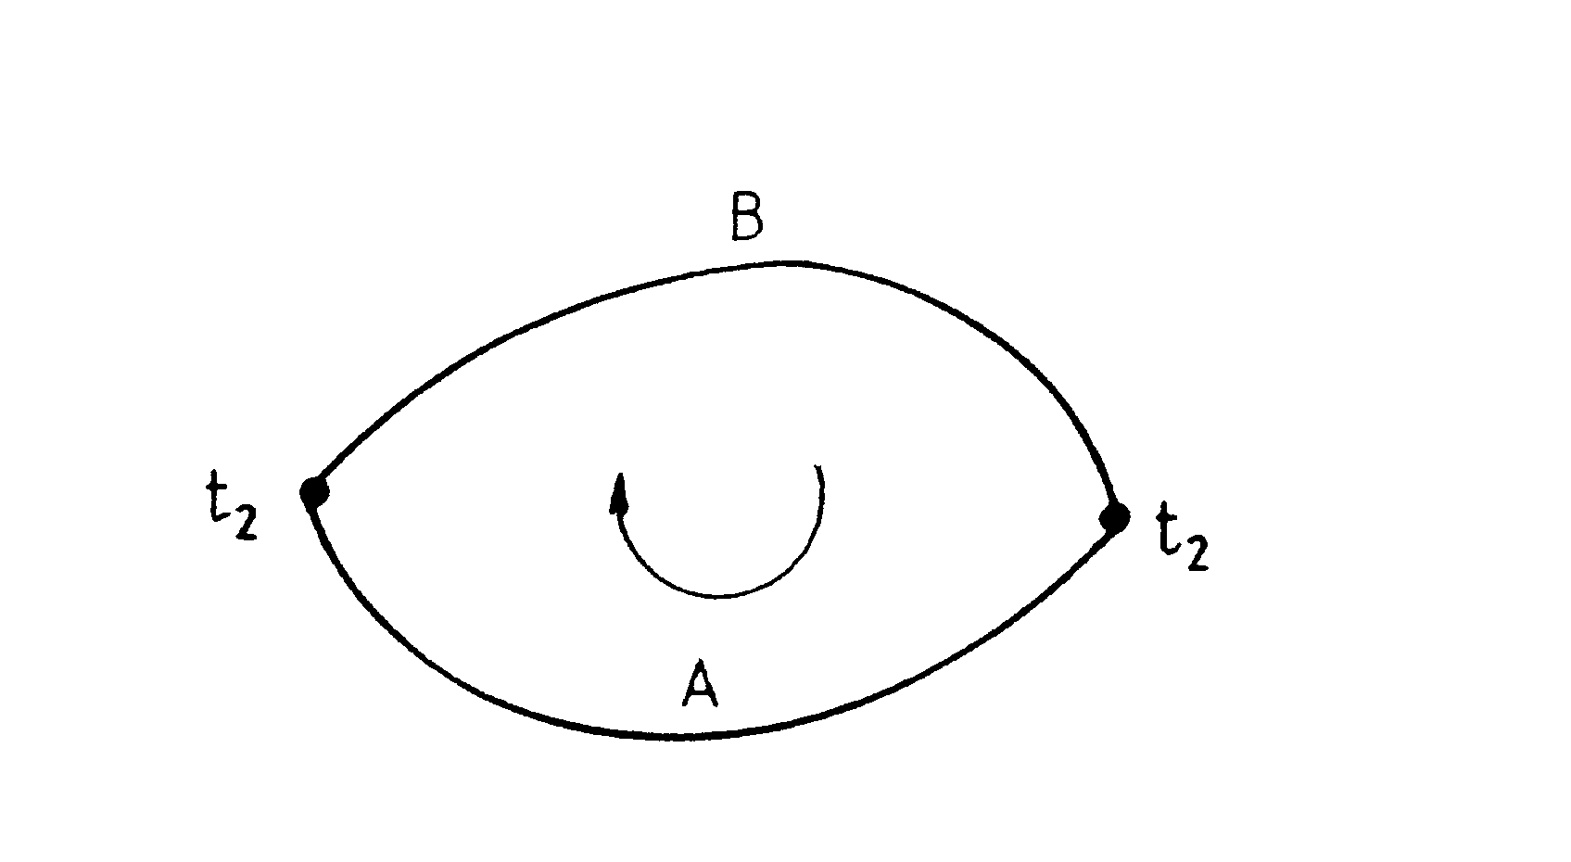
Fig. 5.4

The last two terms give the potentials between the two ends of homogeneous metal wires them the temperature of the two ends is different. It is necessary to note that the last two terms can not give a measurable TEMF by themselves (see below). If an electric current flows across the junctions the measured voltage differs from TEMF and two other effects also appear. One of them is the Joule effect that heats the junctions. The second effect is the Peltier one. If current flows through a thermocouple the Peltier effect decreases the temperature of the hot junction and increases the temperature of the cold junction. The net result is the decreasing of the temperature difference Δt between the two junctions.
There are three laws which are important for understanding the operation of the thermocouples.
i. The law of homogeneous metal. Any nonsymmetrical temperature gradient in a homogeneous wire does not give a measurable TEMF between the two ends of the wire. A consequence of this law is that two different metals are required in a thermocouple circuit for obtaining measurable TEMF.
ii. The law of intermediate metal. The algebraic sum of the thermal potentials in a circuit composed of different metals is zero if all junctions of the circuit are at a common temperature. The relation for three metals is

-U_{AB}(t) = U_{BC}(t)+U_{CA}(t)

The result of this law is that a third homogeneous metal can always be added to the thermo-couple circuit with no effect on the net TEMF (see Fig. 5.5ab). The verification of this statement is
E(t₂ ,t₁ ) = U_{AB}(t₂ )+U_{BC}(t₁ )+U_{CA}(t₁ )+U_{A}(t₂ ,t₁ )+U_{B}(t₁ ,t₂ )

where the sum of the second and the third terms equals to U_{BA}(t₁). Because of this a voltameter or other device can be incorporated into the thermocouple for measuring the TEMF.
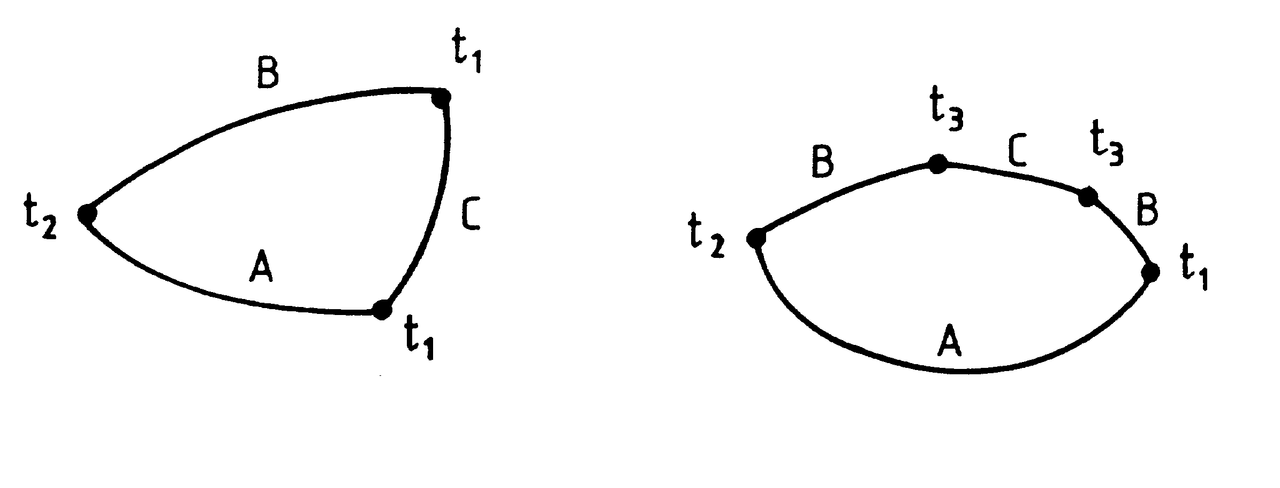
Fig. 5.5a-b

iii. The law of successive temperature. If two different homogeneous metals produce a TEMF of E(t₃ ,t₂) and an other TEMF of E(t₂ ,t₁), the TEMF generated when the junctions are at t₃ and t₁ will be E(t₃, t₂)+E(t₂ ,t₁). The application of this law permits a thermocouple calibrat-ed for a given reference temperature to be used at any other reference temperature applying a suitable correction.
The TEMF can be expanded into Taylor series of Δt as follow

E(Δt) = αΔt+βΔt² +γΔt³

where the temperature coefficients depend on the reference temperature.

5.3.2 Thermocouples applied in the chemical industry

Figure 5.6 shows the TEMF-temperature characteristics of some thermocouple types used in the chemical industry. The reference temperature is 0 ⁰C. Their upper temperature limits and the standardized colour indications are collected in Table 5.

Table 5

thermocouple | t_{max}[⁰C] | colour
Cu-constantanª | 400 | brown
Fe-constantant | 600 | blue
NiCr^{b} - Ni | 900 | green
Chromel^{c} - Alumel^{d} | 1000 | yellow
PtRh^{e} - Pt | 1600 | white

ª 45% Ni + 55% Cr
^{b} 90% Ni + 9.5% Cr + 0.5% Si
^{c} 90% Ni + 10% Cr
^{d} 95% Ni + 2% Al + 2% Mn + 1% Si
^{e} 90% Pt + 10% Rh

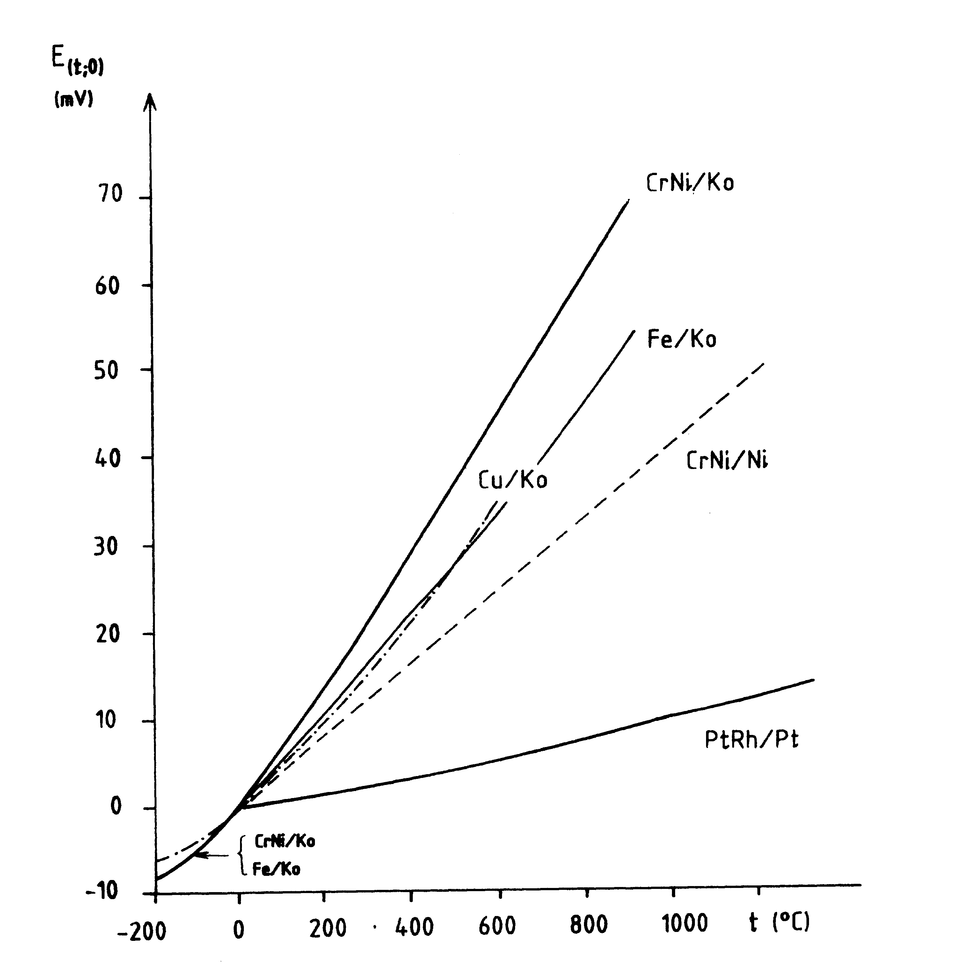
Fig. 5.6

The resistance of the thermocouples is several ohm. For the consistency of the measurements this value has to be completed to a fix resistance. The resultant resistance of the thermocouple circuits without the instrument is usually standardized to be 20 ohm. Figure 5.7 shows a thermocouple assembly.
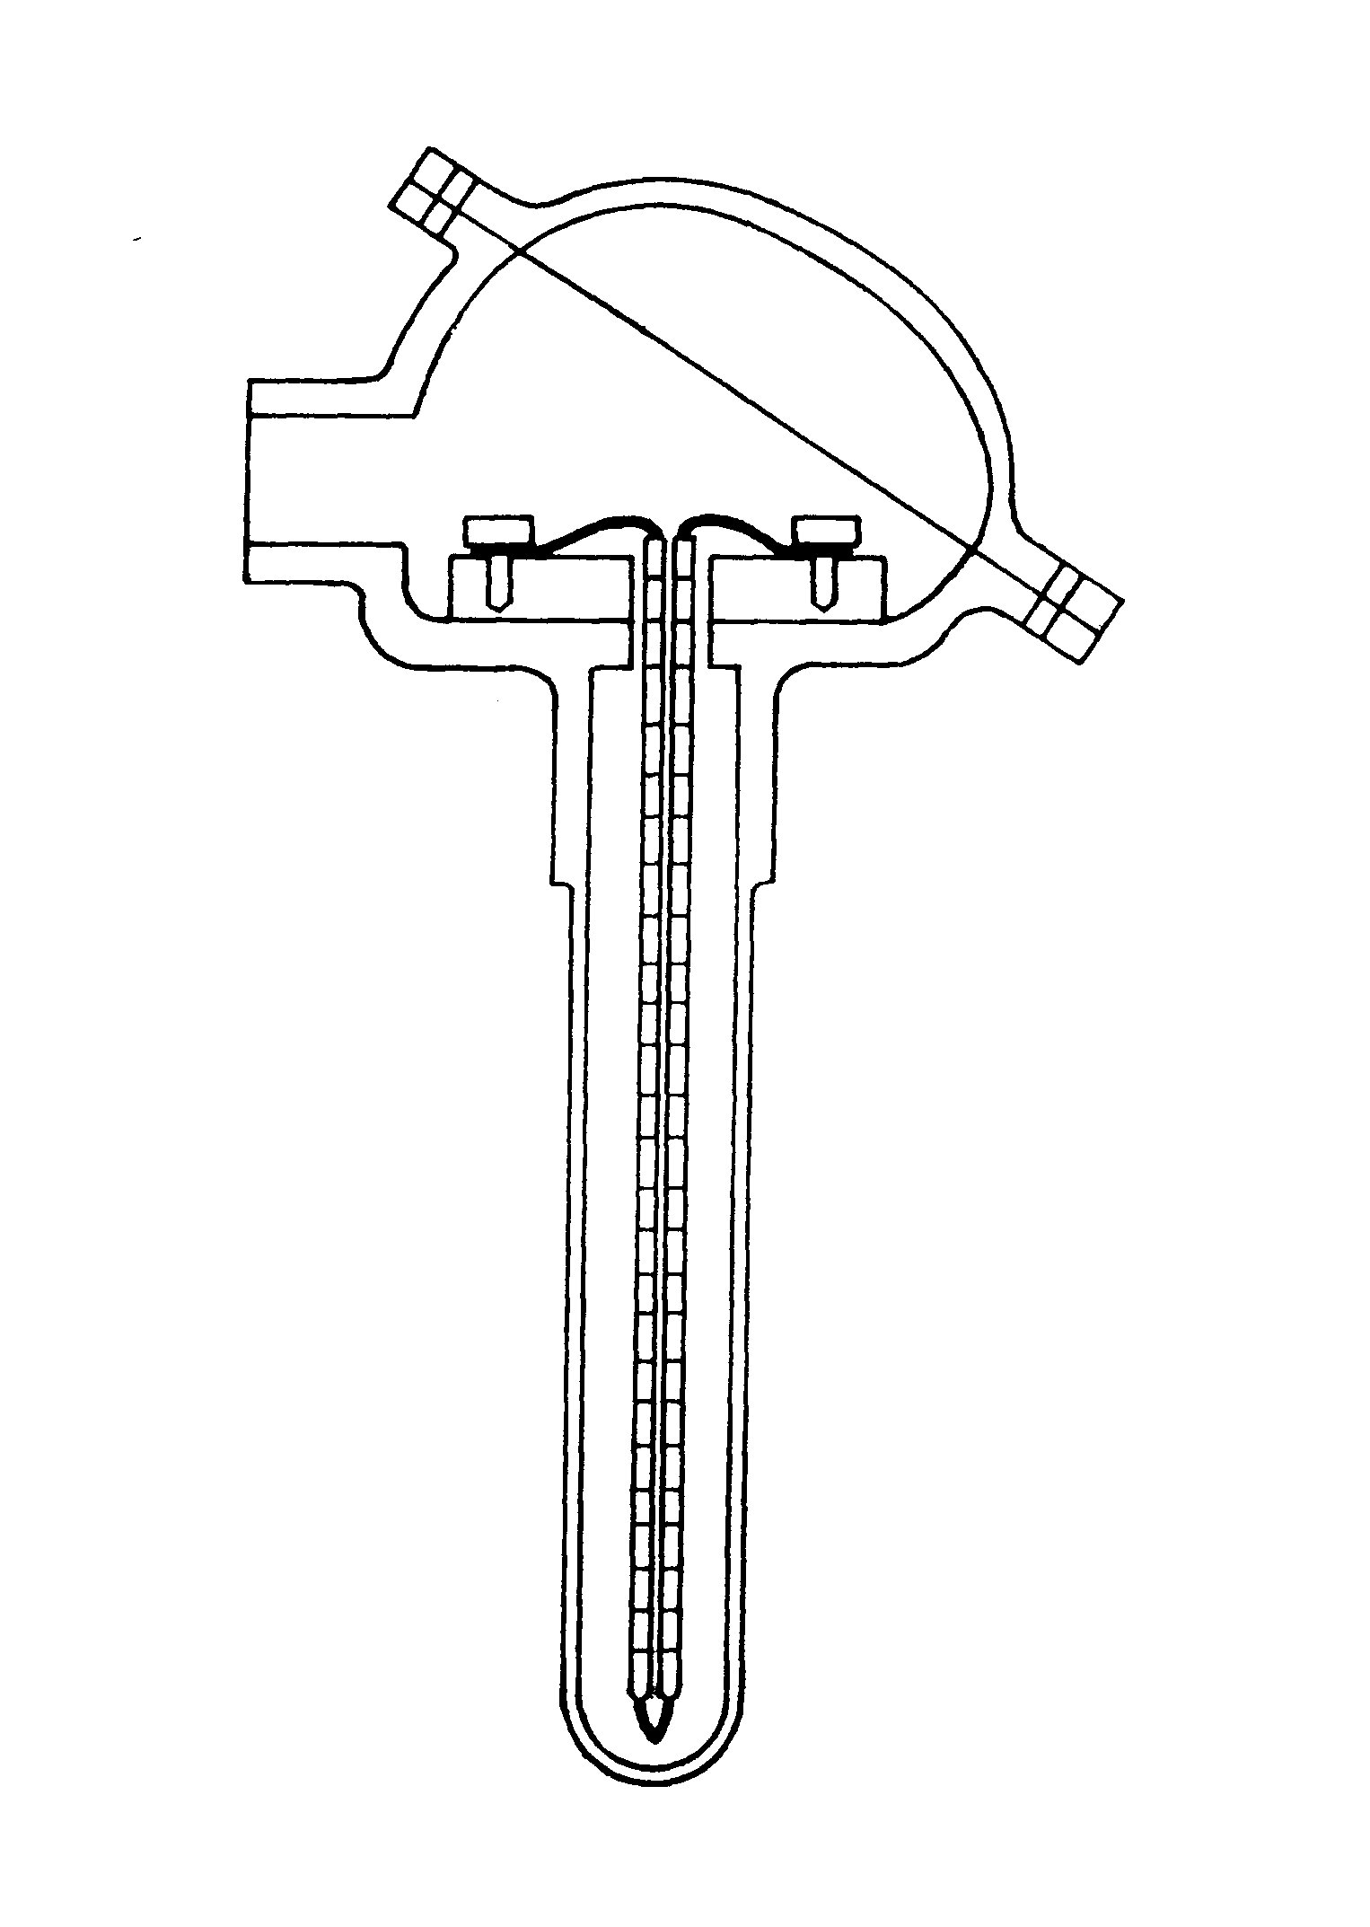
Fig. 5.7

5.3.3 Thermocouple circuits

The fundamental problem of the temperature determination by thermocouples is the thermostability of the reference point. Because of the heat conductivity along the wires, the thermal radiation and the thermal fluctuation of the surrounding the temperature t_{k} of the reference point may change during the measurement (see Fig. 5.8a). There are three widely used methods to eliminate the slipping and fluctua tion problems of the reference temperature.
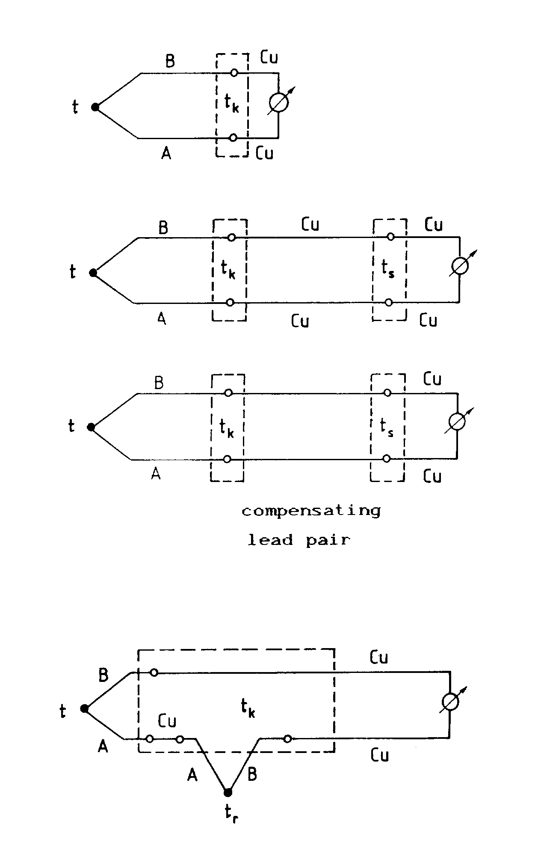
Fig. 8a,b,c,d

i. Thermostabilized junction method. The temperature t_{k} of the reference junctions is stabilized by heating or by cooling (see Fig. 5.8b). The other wires in the circuit are copper. The measured TEMF depends on the difference t-t_{k} and independent of the value t_{s} .
ii. Compensating lead pair method. This method applies special lead pairs for connect-ing the input of the instrument far from the investigated system with the thermocouple output (see Fig. 5.8c). The compensating lead pair has to have a same thermoelectric property as the used thermocouple. The requirement can be realised only in a narrow temperature range (e.g. between 20 and 60 ⁰C) employing nonexpensive alloys. Fortunately the temperature difference between t_{s} and t_{k} does not exceed usually this range. It is temperature t_{s} that has to be stabilized so the measured TEMF depends only on the difference t-t_{s} .
iii. Reference thermocouple method. The circuit contains two opposite connected thermocouples (see Fig. 5.8d). The measured TEMF depends on the difference t-t_{r} . This method is widely used in the laboratory.

5.3.4 TEMF measuring methods

5.3.4.1 Compensation the TEMF by a potentiometer

A potentiometer is an instrument which compensates unknown voltages by a known voltage opposite connected. Figure 5.9 shows an automatically balancing potentiometer. This circuit is very similar to the automatically balancing bridge. The potentiometer is supplied by DC voltage higher than the TEMF of the thermocouple. On the output of the bridge appears a voltage regulated by the balancing. This voltage is opposite connected with the measurable TEMF. The output voltage of the potentiometer is the input one of the operational amplifier. The operational mode of the servo system is identical with the one applied in the automatically balanced bridge.
The main advantage of the potentiometer is that practically no current flows through the thermocouple during the measurement.
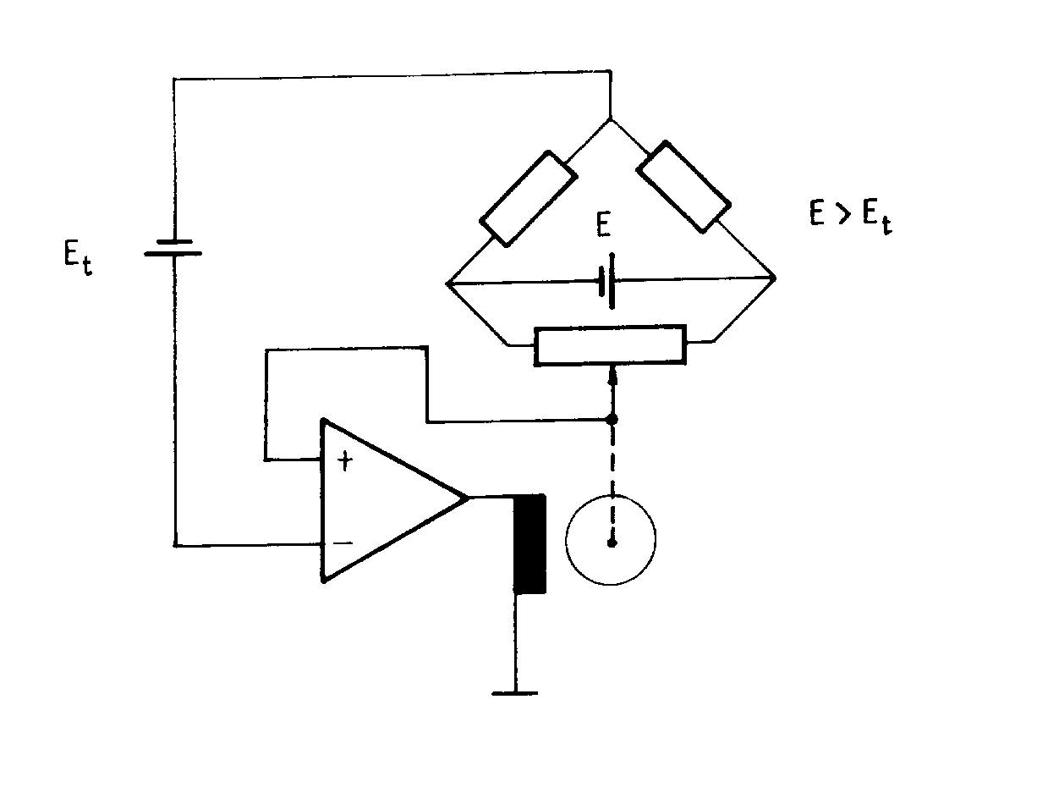
Fig. 5.9

5.3.4.2 Digital thermocouple thermometer

The instrument is very similar to the one described in the section 5.3.2.2 , but the circuit does not contain a CCS. The reference junctions are stabilized thermally. The input resistance of the AD converter is about 1 Mohm or higher which is satisfactory for measuring the electro-motive force. The memory of the microcomputer stores the temperature coefficients α, β, γ and the value of the reference temperature. Using the stored constants the microcomputer calculates the tem-perature from the sampled TEMF.

