6. Flowmeters

All flowmeters contain a measuring element, the output of which is proportional to the average velocity of the liquid or gas stream in a filled, closed pipe. There are many types of flowmeter from which only four types will be discussed.

6.1 Turbine flowmeter

A turbine wheel ("Pelton wheel") is set in the path of the fluid stream so that the rotor axis should be parallel to the flow axis. The tube of the flowmeter is made from nonmagnetic stainless steel. The turbine is set in motion by the flowing fluid. When a steady rotational speed has been reached, the number of turbine wheel revolutions per unit time is proportional to the average velocity of fluid. The frequency of the rotating turbine is transmitted to the electronics by a magnetic sensor (transducer). The sensor consists of a permanent magnet (one of the rotor blades) and a pickup coil which is mounted in close proximity to the rotor but external to the pipe. The passage of the rotor blade changes the magnetic flux around the coil inducing fluctuated voltage in the coil. The electronics converts the fluctuated output voltage of the transducer into an impulse wave signal. The number of pulses per unit time is determined by a digital counter. The frequency of the impulse wave is a measure of the flow rate and the total number of pulses is a measure of the total volume (or mass) flowed through the pipe. The rotor of the turbine flowmeter included in the pipe slightly modifies the pressure distribution in the flowing fluid along the pipe. Fortunately the modified pressure distribution does not change during the time of the measurement. The magnetic coupling for transmitting the rotation frequency of the turbine wheel into the electronics offers a connection without reaction. Because of the rotating element it may be a problem if the flowing liquid is dirty. A fat fibre layer may modify the rotation frequency of the turbine wheel requiring a cleaning and new calibration.

6.2 Magnetic flowmeter

The magnetic flowmeter can measure the average velocity of flowing electrolyte. The method is relatively insensitive to the changes in fluid density, viscosity and the flow velocity profile. It has a linear response and is particularly suitable for measuring the flow of highly corrosive acids and alkalis. Its operation is undisturbed by coarse or fine suspended materials in the fluid. The magnetic flowmeters does not modify the pressure distribution in the flowing fluid along the pipe. Figure 6.1 shows a magnetic flowmeter. The tube of flowmeter is constructed of nonmagnetic stainless steel and is covered by insulating material (p.e. polytetrafluoroethylene) to minimize the probability of short-circuiting. An oscillating magnetic field perpendicular to the flow axis is generated in the electrolyte by an electromagnet supplied with AC current. The operation of the magnetic flowmeter is based on the electromagnetic induction. The induced voltage is detected by a pair of electrode located diametrically opposite sides of the tube. The axis of the electrodes is perpendicular to both the oscillating magnetic field and the axis of the tube.When sinusoidal excitation of the electromagnet is used, the induced voltage is

where ω is the angular frequency of AC current in the coil of the electromagnet, B_{o} is the amplitude of the oscillating magnetic field, D is the diameter of the flowtube, c is a constant and is the average velocity of the fluid in the flow tube.
The first term in the above relation is a flow-dependent one which is in phase with the change of the magnetic field. Being independent of the flow the second term is an unwanted component of the induced voltage. This latter voltage arising purely from the alternating magnetic flux is eliminated from the amplified signal by the electronics of the flowmeter with help of a phase-shifted part of AC current in the electromagnet.

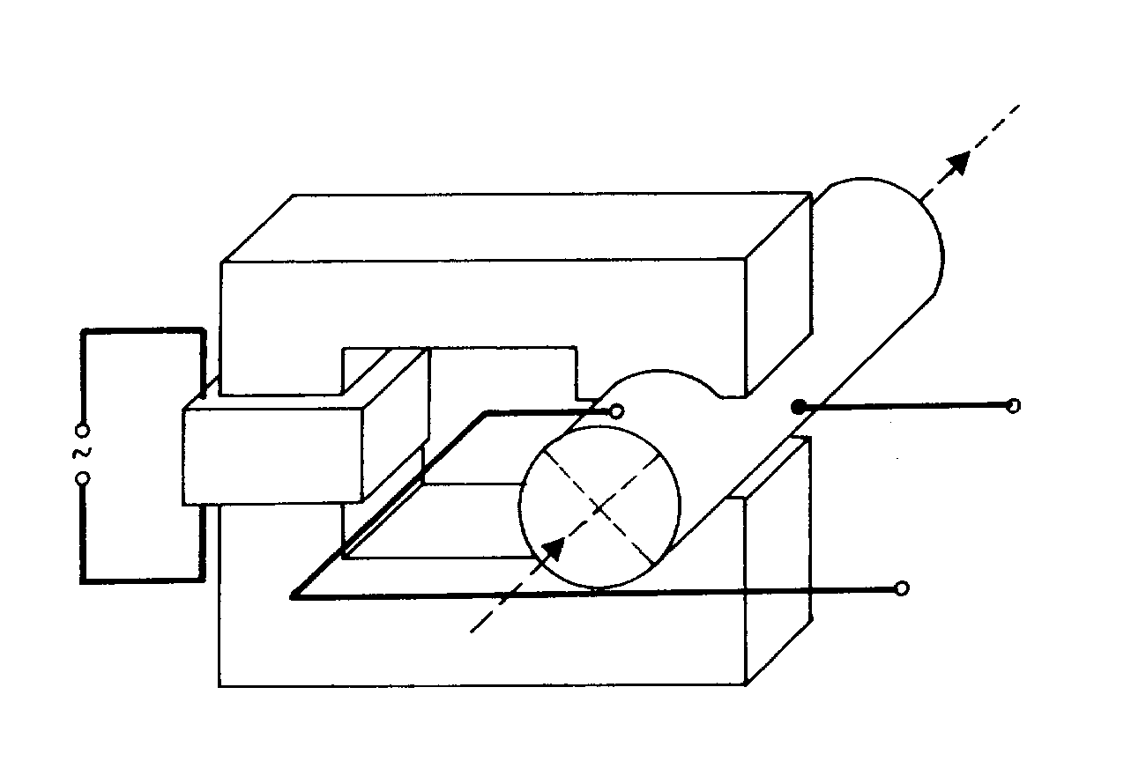
Fig. 6.1

6.3 Vortex flowmeter

The phenomenon and the principle of vortex shedding has been known for many years (Th. von Kármán), it has been applied to flow measurement in the practice only during the last three decades.
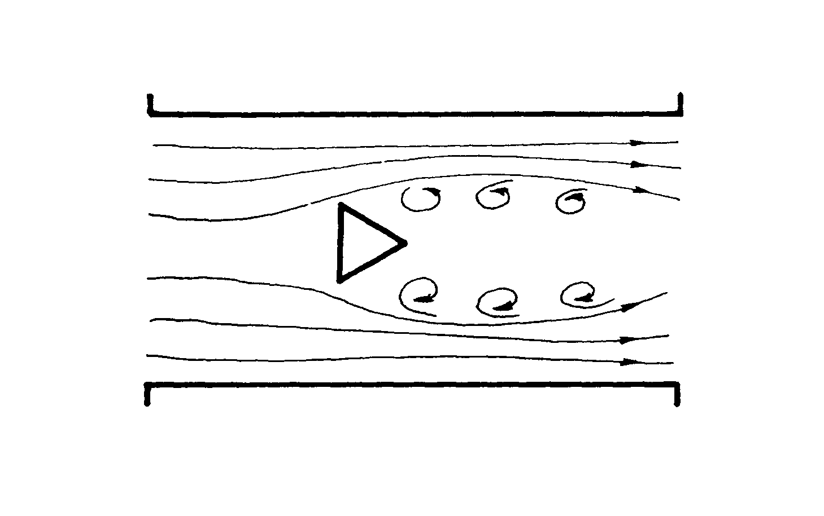
Fig. 6.2
Figure 6.2 shows the vortex shedding phenomenon. This phenomenon of flowing fluid can occur when a nonstreamlined obstruction body (or test body) is placed in a fluid stream. A vortex chain appears both sides of the obstruction body. The vortex chains are shedding with a periodicity proportional to the average velocity of the flowing fluid. The shedding of vertices creates a fluctuated pressure difference between the front and the end of the obstruction body. Applying a suitable sensor a fluctuating electric signal proportional to the pressure difference can be obtained. The electronics converts the periodic electric signal to a impulse square wave. A digital circuit counts the number of pulses per unit time. After calibration the numerical value obtained gives the flow rate of the fluid or the volume flowed through the pipe.
A common requirement for the sensors is the small time constant. There are many types of sensors working well in filtered liquids but not working well in dirty ones because a coating from the flowing fluid increases the time constant of the sensor. In such cases the sensor has to be placed in a cavity of the obstruction body closed by diaphragms and filled by a pressure conducting medium (e.g. silicon oil).
One of the appropriate sensors is an assembly consisting of a nickel sheet which can oscillate with the periodicity of the vortex shedding. The vibrating nickel sheet modifies the magnetic field of a pickup coil inducting voltage fluctuation in this sensor coil. Another possible sensing device is a piezo-electric crystal which produces a periodic voltage output when the pressure difference changes periodically. This voltage fluctuation is converted into impulse square wave by the electronics.

6.4 Ultrasonic flowmeters

There are two types of ultrasonic (or acoustic) flowmeter, Doppler-effect flowmeters and transit-time flowmeters. In both types the flow rate is deduced from the Doppler-effect of the fluid stream on ultra-sound waves propagating in the fluid. The principle of ultrasonic flow measurement have been known for many years, but the importance of this method in the flow measurement has increased in the last two decades. The ultrasonic flowmeters have numerous advantages over most of the traditional methods. The ultrasonic flowmeters which can be used bidirectionaly have linear response. The ultrasonic heads do not induce pressure drop and do not disturb the flow stream. They are not expensive. The working of Doppler-effect flowmeters requires the existence of solid particles or air bubbles in the fluid stream for reflecting the ultrasonic beam, for the transit-time flowmeters, however, it is undesirable to be a large amount suspended particles in the flow stream because their presence reduces the intensity of the ultrasonic beam.
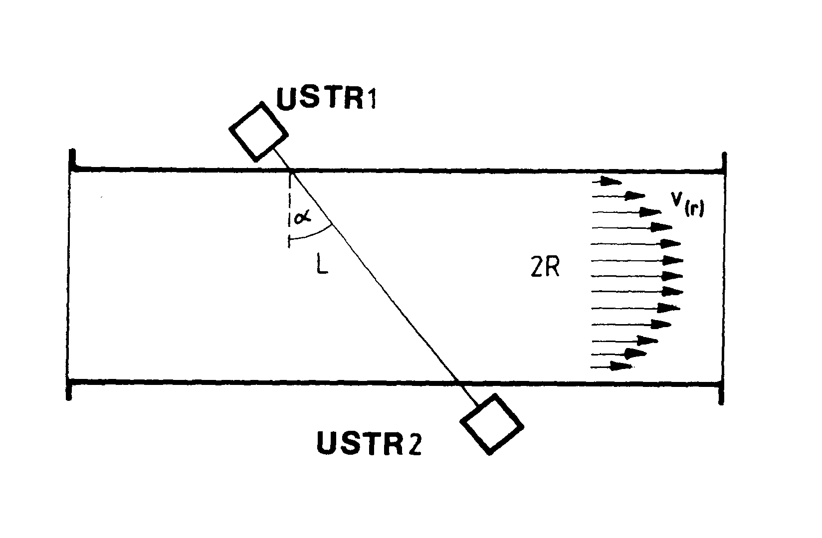
Fig. 6.3
Figure 6.3 shows a transit-time flowmeter. There are two ultrasonic transmitter-receiver devices (USTR) located opposite each other. The angle between the axis of the two USTR and the perpendicular direction to the flow axis is α. Both devices contain piezoelectric crystals attached to moving-coil speakers (loud-speaker). If a periodic electric signal (f >20 kHz) is switched to a piezoelectric crystal the crystal performs a mechanical oscillation with frequency f_{o} vibrating the loud-speaker. If an acoustic signal is received by the diaphragm of loud-speaker, the mechanical vibration transmitted to the piezoelectric crystal causes an electric charge fluctuation between the two sides of the crystal. The electronics converts this charge fluctuation to amplified voltage signal. The upstream and downstream transit-times of the ultrasonic beams are different,

and

where t₊ is the upstream and t₋ is the downstream time, L is the distance between the input and output windows made from epoxy resin, c is the velocity of the ultrasonic waves in the nonflowing fluid and is the average velocity of the flowing fluid. The relation between the average velocity and the velocity distribution v(r) in the flowing stream is

From the upstream and the downstream times the average velocity can be determined by a microprocessor based electronics with help of the relationship

,

from which the c velocity disappears due to the mathematical manipulation.
The nonzero transit-time difference between the forward and the reverse ultrasonic beams is based on the Doppler-effect. In 1842, Ch. Doppler predicted that the frequency of a received wave was dependent on the motion of the source or observer relative to the propagating medium. In our case the fluid in the pipe is that moves relative to the fixed source and receiver.

