7. Pressure measurement

Only one method will be discussed. The unit of the pressure is the bar (1 Nm⁻¹) in SI.

7.1 Piezoresistive pressure transducer

If the pressure acts to a solid body modifying its crystal structure the specific resistance of the body will change. Piezoresistive pressure transducers are made from metals or semic-onductors. The sensitivity of semiconductor piezoresistive devices are higher then the one of the metal devices. The sensitivity is given by the piezoresistive coefficient β as follow
,
where R is the resistance of the piezoresistive device and p is the pressure. The sign of the coefficient may be positive or negative depending on the material and the orientation if the resistance is cut from a monocrystal.
The metal piezoresistive transducers are applied solely at high pressure (>400 bar) and the semiconductor ones at low pressure (<400 bar).
Figure 7.1 shows the sensing element of a semiconductor piezoresistive pressure transducer. This sensing element consists of four nearly identical p type piezoresistors formed by diffusion on the surface of a thin n type silicon layer cut from a monocrystal with a given orientation. Two from the four resistors (R_{r}) lies in radial direction and the two other ones (R_{t}) are perpendicular to the radial direction axis. The pressure which acts to the sensing element through a diaphragm and a pressure conducting medium (silicon oil) causes the bend of the silicon layer inducing a stress or strain tension in the radial resistances and a torsional tension in the R_{t} resistances. The resistances will change depending on the tensions appeared in the resistors. These tensions depend on the pressure applied to the Si layer and the positions of the resistors on the surface of this layer. Figure 7.2 shows the distribution of the mechanical tensions and as a function of the radial coordinate. It can be seen that in an appropriate position the radial tension can be
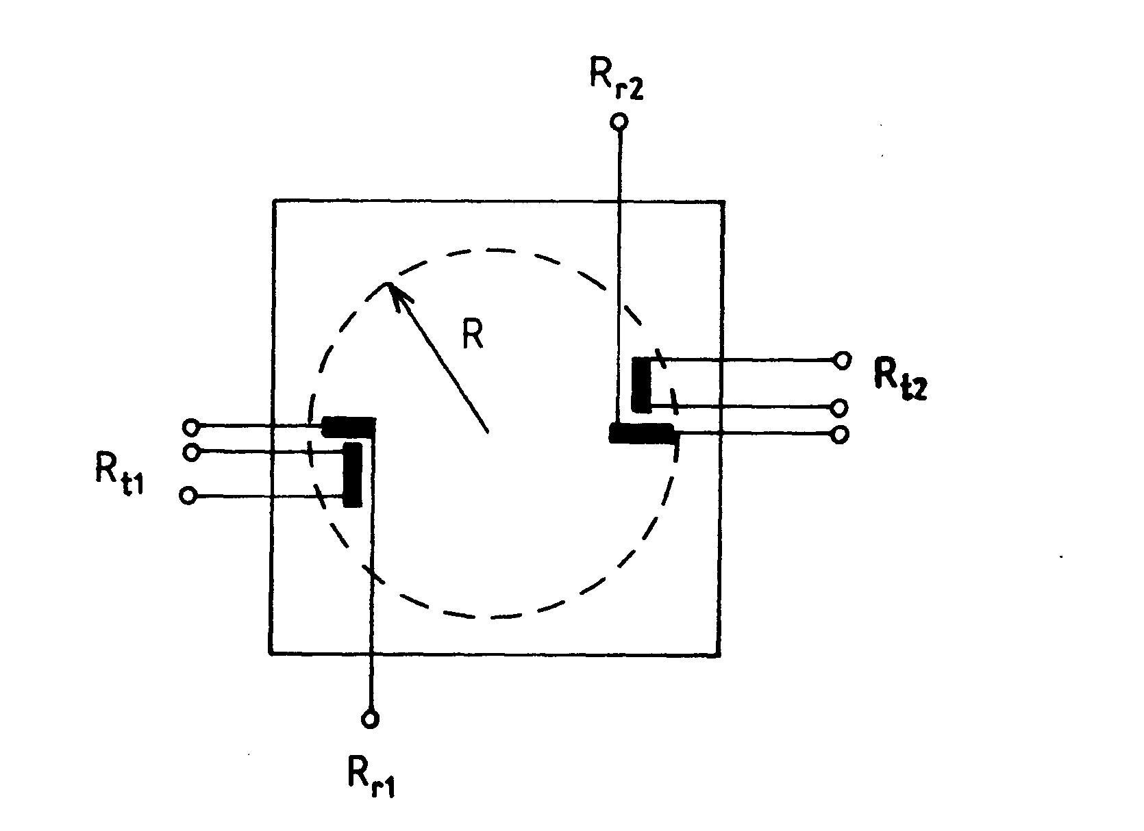
Fig. 7.1
neglected and the torsional tension has a maximal value in this position. Forming the resistors R_{r} and R_{t} on these positions of the surface the resistors R_{r} do not deform practically during the measurement. The resistors are connected in a full Wheatstone bridge in which the resistors R_{r} are the reference ones (see Fig. 7.3). The bridge is powered by a constant current source (CCS). The constant current is the output one of a current generator circuit which contains an operational amplifier with a negative feedback loop. On the noninverting input of the operational amplifier is a stabilized voltage U_{t}. The negative feedback has two roles, it guarantees the elimination of the effect of the change in the bridge load and of the change in the temperature. Because of this latter role the feedback circuit includes thermistors (TH3 and TH4), too. The bridge itself is temperature compensated what is assured by the reference resistors and the thermistors TH1 and TH2. Unfortunately this temperature compensation is satisfactory only in a relatively narrow temperature range, about from -40 C to 120 C. The piezoresistive pressure transducers require a careful adjustment and calibration in the factory.
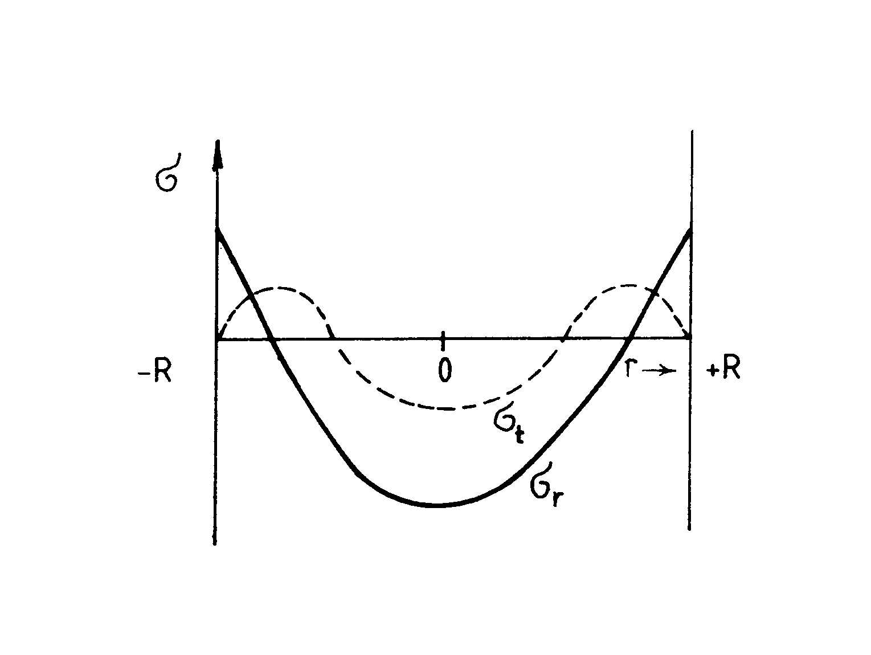
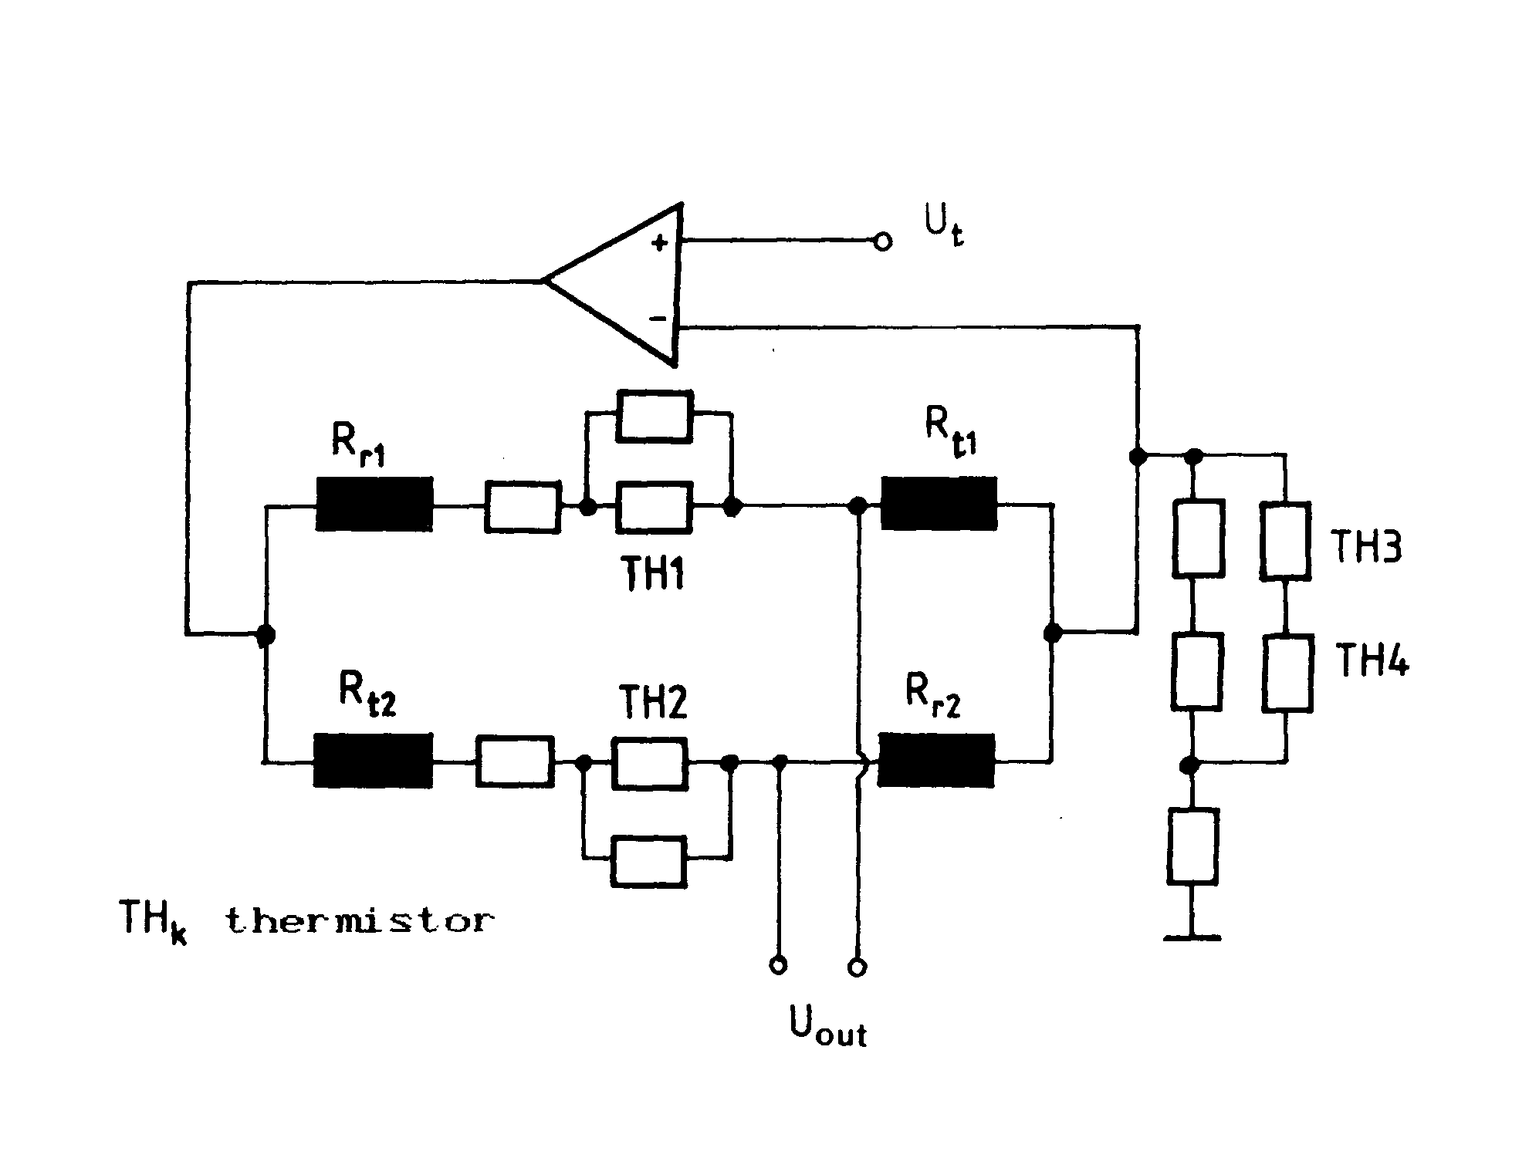
Fig. 2 and 3
The transducers in the chemical process industry are generally completed by transmitter. The transmitter is an electronic device which is used to interface the upper and the lower limit of the working range of the instrument to standardized current values. According to recommenda-tion of IEC (International Electrotechnical Commitee) 4 mA DC current has to flow in the transmitter loop at the lower limit of the working range and 20 mA DC current has to flow at the upper limit (see Fig. 7.4). The output current can be synchronized to the standardized values by the adjustment of the transmitter. This transmitter system called living zero one requires two wires only. If the instrument, the transmitter (interface) and the receiver are connected by a common earth a third wire is also necessary. The voltage necessary for supplying the instrument and the interface can be usually generated from the current of the transmitter loop.
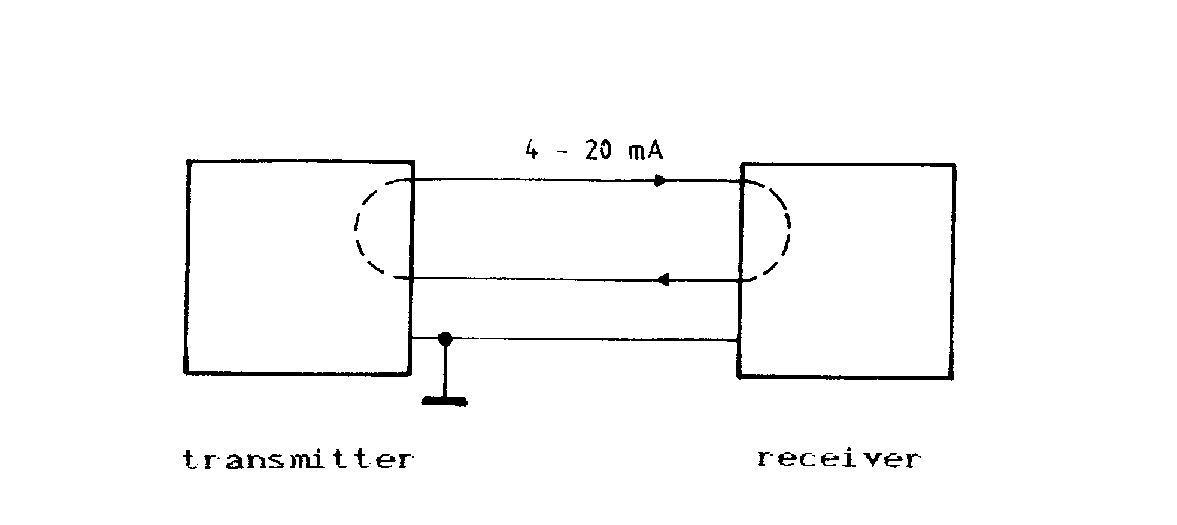
Fig. 7.4

